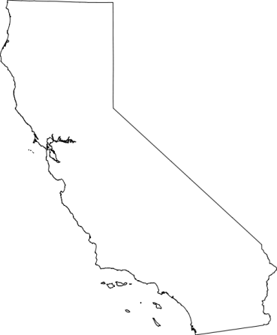
USDA Forest Service
Pacific Southwest Region
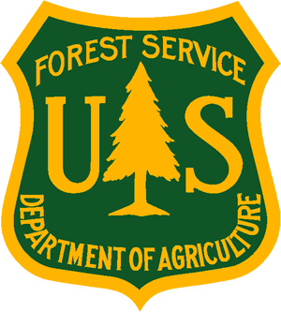
_______________________________
Outreach Notice
Eldorado National Forest
Seed Bank Manager
___________________________________

Biological Scientist-Seed Bank Manager
GS-0401-7/9
Permanent Fill Opportunity

OUTREACH INTEREST FORM
Seed Bank Manager
Eldorado National Forest

Please respond by 8/31/2021

If you are interested in this position, please complete this Outreach Interest Form and email Gary Cline at gary.cline@usda.gov

NAME:
E-MAIL ADDRESS:
MAILING ADDRESS
TELEPHONE NUMBER
CURRENT REGION/FOREST/DISTRICT
CURRENT SERIES/GRADE
CURRENT POSITION TITLE

