Rocky Mountain Region
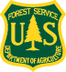
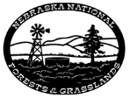
Nebraska National Forests and Grasslands
Outreach for Horticulturist
GS-0437-05/07/09
Bessey Nursery, Halsey, NE

If you are looking for an exciting career in Horticulture here is your chance. The Charles E. Bessey Nursery will soon be advertising a Horticulturist position located at the Oldest Federal Tree Nursery near Halsey NE.
- The position Serves as an interdisciplinary team member in the planning, scheduling, growing, harvesting and distribution of seedling crops and plant materials from greenhouses and bareroot production fields.
- Prepares work plans and production schedules, coordinates activities with other departments, and monitors and protects of crops.
- Monitors and adjusts growing environments, observes seedling conditions, monitors for insect and disease, and takes necessary corrective measures including the application of pesticides in a greenhouse environment.
- Assists in the supervision of subordinate employees conducting seeding, fertigation, crop protection and harvesting activities ensuring that all activities are performed in a safe manner.
- Assists with field preparation, seed stratification schedules, seed sowing, irrigation, insect and disease monitoring, the application of fertilizers and pesticides. and the harvesting and packing of the crop in bareroot production. Assists the supervisor in the supervision of these activities by subordinate employees insuring that they are done in a safe manner.
- Assists with regional cone collection programs and supervising the extraction, cleaning and storage of conifer seed. Oversees seed testing procedures and assures that all tests are complete and accurate. Participates in the preparation of financial and work plans for assigned programs by estimating, combining, and coordinating project plans into an annual unit work plan. Reviews work accomplishments for assigned areas of responsibility and compiles necessary reports.
- Additional duties will include preparation and maintenance of accurate inventory records of available seedlings using ACCESS database and updating seedbank data in the nursery NMIS database. Some of the additional fieldwork duties include but are not limited to sowing seed, irrigation (greenhouse and field), grading seedlings, weeding, and seed collection/processing, seedling inventory, fence repair, pesticide applications and much more. A Pesticide and Chemigation license is required and can be obtained within the first 6 months of work.
In return, we are looking for a hard worker with a great attitude. Our talented and dedicated employees are among the best you’ll find anywhere.
If interested, please reply to this outreach by submitting the attached form to regilbert@fs.fed.us by July 24, 2015. The vacancy announcement has not yet been advertised, but we expect to do so early August. When advertised, it will be posted on USAJOBS at www.usajobs.opm.gov. This outreach notice will be updated with the vacancy information once it is announced. Everyone who responds to this pre-announcement will be e-mailed the information about the vacancy’s announcement.

For more information about this outreach notice or the position, please contact:
Richard Gilbert, e-mail: regilbert@fs.fed.us
Phone: (308) 533-8117 Fax: (308) 533-2310

About Halsey, Nebraska

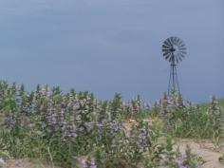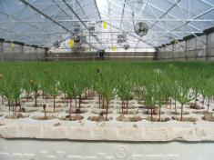

The Bessey Ranger District is located one mile west of Halsey, Nebraska, in the central part of the state in the scenic “Sandhills”. The area is beautiful, but remote. Halsey has a population of approximately 60, a post office, tavern/restaurant, and a motel. Limited services such as banks, grocery stores, gas stations, county government offices, and churches are located in the surrounding communities. Full service communities are a one-hour drive or more, and include Broken Bow (55 miles), Valentine (70 miles), and North Platte (90 miles). The primary industries in this area are ranching and agriculture. Cell phone and wireless service can be spotty; local carriers work better than national carriers such as Verizon. Home internet service is available and works very well.

Recreational activities abound for residents and visitors to the area. The Sandhills is a popular destination for hunting, fishing, and many other outdoor activities. Tubing, kayaking, and canoeing are popular on the Middle Loup, Dismal and Niobrara Rivers in the summer time. The public lands in the Sandhills provide an excellent place to hunt sharp-tail grouse, prairie chickens, mule and whitetail deer, and pronghorn. In addition, three world-renowned golf courses are within an hour’s drive of Halsey along with a well-maintained, nine hole course in Thedford, 14 miles away.

The average January temperature is 10º F and an average July temperature is 89º F. Average precipitation is 21 inches, and average snowfall is 31 inches. Elevation is 2,880 feet above sea level.

Rentals range from $250 to $300 per month in nearby Thedford and $300 to $360 a month in Broken Bow. The average cost of a home is approximately $130,000 in Thedford and $135,000 in Broken Bow. Nebraska does have a State Income Tax (http://www.revenue.ne.gov).

There is a consolidated school system, which serves four local school districts. K through 6th grade students attend classes in Halsey, and 7th through 12th grade students are bussed to Dunning, a community 10 miles to the east. It’s a great place to live without the bright lights, with a slower pace of life, and great outdoor recreation such as hiking, biking, hunting and fishing.

About the Nebraska National Forests and Grasslands
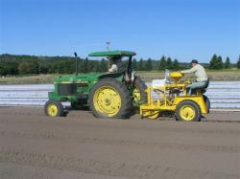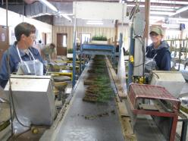

Quick Facts
- Responsible for the management and sustainability of the Bessey Nursery, the nation’s oldest Federal Nursery and listed on the National Register of Historic Places.
- Home to the largest hand-planted forest in the western hemisphere, second only to Johannesburg South Africa.
- Internationally known Hudson-Meng Research and Education Center encompasses the largest extinct bison bone bed in the world; and Toadstool Geological Park and the National Grasslands Visitor Center
- A diverse wildlife program with numerous partnership agreements for habitat improvement that support species like the Black Footed Ferret, Burrowing Owl, and Black Tailed Prairie Dog.
- Significant populations of hunt-able and viewable wildlife such as wild turkey, mule and white-tailed deer, and elk.
- An aggressive forest and grassland health program, with wild land/urban interface.
- Soldier Creek Wilderness, two proposed Grasslands Wilderness Areas and Pine Ridge National Recreation Area.
- Developed campgrounds and over 100 miles of hiking trails
- Over 300 grazing allotments, 60 direct permittees, and seven grazing associations

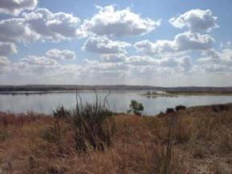

The Nebraska National Forests and Grasslands encompass over 1.1 million acres of land in Nebraska and South Dakota, administered by five Ranger Districts and one Nursery. The Pine Ridge Ranger District includes the Nebraska National Forest and Oglala National Grassland in the northwest corner of Nebraska. The Bessey Ranger District includes a portion of the Nebraska National Forest in west-central Nebraska and the McKelvie National Forest in north-central Nebraska. The Bessey Nursery is co-located with the Bessey Ranger District at Halsey, Nebraska. The Fall River Ranger District and Wall Ranger District share management of the Buffalo Gap National Grassland across southwestern South Dakota. The Fort Pierre National Grassland, situated in south-central South Dakota, is managed by the Fort Pierre Ranger District.

The Nebraska units have approximately 85 permanent employees and approximately 35 temporary employees. The Supervisor’s Office located in Chadron Nebraska and is staffed with approximately 35 employees and is co-located with the Pine Ridge Ranger District. The Pine Ridge Job Corps Center is located 10 miles south of Chadron, Nebraska and is a close partner with the Nebraska National Forests and Grasslands.

More information regarding the Forest is available through the internet at: www.fs.fed.us/r2/nebraska .

Map of the Nebraska National Forests and Grasslands

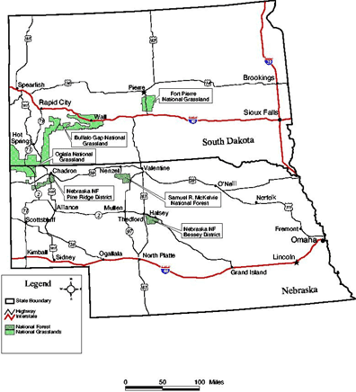

Outreach Form
Nebraska National Forests and Grasslands
Horticulturist, GS-0437-05/07/09
Please respond to this outreach by July 24, 2015 to Richard Gilbert at regilbert@fs.fed.us
NAME:

E-MAIL:

MAILING ADDRESS:

TELEPHONE NUMBER:

AGENCY EMPLOYED WITH: USFS BLM OTHER (where?)

TYPE OF APPOINTMENT: PERMANENT OTHER

CURRENT REGION/FOREST/DISTRICT/EMPLOYER (if applicable):

CURRENT SERIES AND GRADE:

CURRENT POSITION TITLE:

WORK EXPERIENCE:

EDUCATIONAL BACKGROUND:

IF NOT A CURRENT PERMANENT (CAREER OR CAREER CONDITIONAL) EMPLOYEE,
ARE YOU ELIGIBLE TO BE HIRED UNDER ANY OF THE FOLLOWING SPECIAL
AUTHORITIES?

______ PERSON WITH DISABILITIES
______ VETERANS RECRUITMENT APPOINTMENT
______ DISABLED VETERANS W/30% COMPENSABLE DISABILITY
______ VETERANS EMPLOYMENT OPPORTUNITIES ACT OF 1998
______ FORMER PEACE CORPS VOLUNTEER
______ PATHWAYS PROGRAM
______ OTHER ______________________________________________________________

Thank you for your interest in our Vacancy!

The U.S. Department of Agriculture (USDA) prohibits discrimination in all its programs and activities on the basis of race, color, national origin, age, disability, and where applicable, sex, marital status, familial status, parental status, religion, sexual orientation, genetic information, political beliefs, reprisal, or because all or part of an individual’s income is derived from any public assistance program. (Not all prohibited bases apply to all programs.) Persons with disabilities who require alternative means for communication of program information (Braille, large print, audiotape, etc.) should contact USDA’s TARGET Center at (202) 720-2600 (voice and TDD). To file a complaint of discrimination, write to USDA, Director, Office of Civil Rights, 1400 Independence Avenue, S.W., Washington, DC 20250-9410, or call (800) 795-3272 (voice) or (202) 720-6382 (TDD). USDA is an equal opportunity provider and employer.

