Austin Peay State University Center of Excellence for Field Biology’s
Mt. Cuba Center Graduate Fellowship in Eastern American Botany

How to Apply

Austin Peay State University’s Center of Excellence for Field Biology is pleased to offer two Graduate Research Assistantships to support two masters-level graduate students for two years to work in tandem on a taxonomic study of Clematis subgenus Viorna of eastern North America. These assistantships are made possible by funding from Delaware’s Mt. Cuba Center.
Mt. Cuba Center, a premier native plant garden, is dedicated to supporting the environment through the practice and promotion of ecological horticulture. Mt. Cuba Center’s gardens and programs inspire an appreciation for the beauty and value of native plants and commitment to protect the habitats that sustain them.
Each assistantship provides an $18,000 per year annual stipend, full tuition waiver, travel funding and vehicle usage for research, funding to present at regional and national conferences, and a modest per diem and lodging stipend for fieldwork. It will also provide for a two-weeks stay at Mt. Cuba Center to work with botanical garden staff.
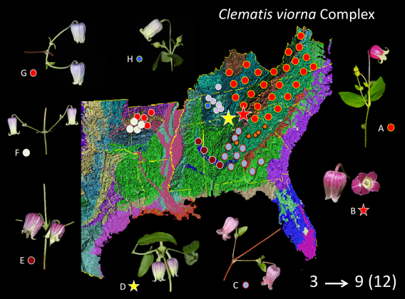
The chosen applicants will conduct a taxonomic study of the genus Clematis subgenus Viorna (leatherflowers), a group of approximately 25 species of vines found throughout eastern temperate U.S. The two successful candidates will be required to spend several weeks together in the field over a two-year period traveling across approximately 20 states from New Mexico and Kansas east to Florida and Virginia to collect specimens from approximately 115 populations. Research assistants will be expected to: prepare high-quality herbarium specimens, collect seeds or transplants for living collections, assemble a set of high-quality photographs for each species, collect flowers to preserve in liquid preservative, and collect leaf tissue for molecular studies. Also, students will be required to maintain living collections in the botanical garden and greenhouse at Austin Peay State University, which will require regular tending in the greenhouse and botanical garden until they can be transported later to Mt. Cuba Center where they will form the world’s premier collection of the American leatherflowers.

This position requires 30-40 hours of work per week during summers and 20 hours per week during the spring and fall semesters. Work duties will consist of a mix of duties in the field, herbarium, greenhouse, botanical garden, and lab. Each RA will be assigned to work on a taxonomic study of a group of species of Clematis for her/his thesis. One will work on the taxonomy of the Clematis viorna species complex and the other will work on the taxonomy of the Clematis reticulata complex. Applicants will be expected to submit their results for publication at the conclusion of their projects.
Minimum Requirements:
- Eligible candidates must be able to start the position no later than May 15, 2017
- Must have a B.S. degree in botany, plant biology, ecology & evolutionary biology or related degree
- B.S. degree must have been earned within the past two years
- Undergraduate GPA ≥3.0 is strongly preferred, with strong record of success in science classes
- GRE scores and all other requirements must meet APSU Dept. of Biology minimum standards
- Must have substantial prior experience with floristics, plant identification, use of technical dichotomous keys, and should have good understanding of the major plant communities of the eastern U.S.
- Must have had at least one college course devoted to field botany or taxonomy (course titles may vary but may include local flora, field botany, plant taxonomy, plant systematics)
- Ideal candidates should be able to identify a minimum of 100 vascular plant species by sight;
- Candidates who plan to continue after their masters to PhD programs are preferred. The assistantship is administered by the Austin Peay State University Center of Excellence for Field Biology. Recipients will be selected by Dr. Dwayne Estes, professor of Biology at APSU.
- Must be able to attend a week-long training session, May 15-19, 2017
- Must be able to participate in extended fieldtrips during summers of 2017 and 2018 for up to 3 weeks at a time
- Must be able to handle solitary fieldwork, fieldwork with others for extended periods far away from home, rigorous field conditions (heat, rain, rugged hiking, ticks)
- Successful candidates will begin coursework at APSU in August 2017.
Please submit the following (as hardcopy):
- a 1-2 page cover letter
- a 2-3 page essay (with 5 bibliographic references) addressing the question: Why is botanical exploration and plant taxonomic research still needed in the heavily botanized eastern U.S.? Essay should be set in 11 pt Times New Roman font, single-spaced (proposals should be detailed and will be treated as confidential, and should include five bibliographic references from the primary literature; proposals longer than three pages will be considered ineligible).
- a current curriculum vitae
- three letters of recommendation, both references should address why they consider the candidate to be highly qualified for this research assistantship in plant taxonomy (these must be emailed by your letter writers directly to Dr. Estes and must cc Mrs. Jean Langley (langleyj@apsu.edu).
All applicants should also be aware that formal applications need to be submitted to APSU’s graduate program in order to be admitted to the University and to the Dept. of Biology. Please go to http://www.apsu.edu/biology/graduate/gradadmiss and follow all directions to apply. These materials should be submitted by March 1, 2017.
Mail applications to: Dr. L. Dwayne Estes, Austin Peay State University, Dept. of Biology, P.O. Box 4718, Clarksville, TN 37044 USA
Additional information may be obtained by contacting Dr. Estes at the address above or by email at estesL@apsu.edu. Final proposals to Dr. Estes must be received by March 15, 2017.

