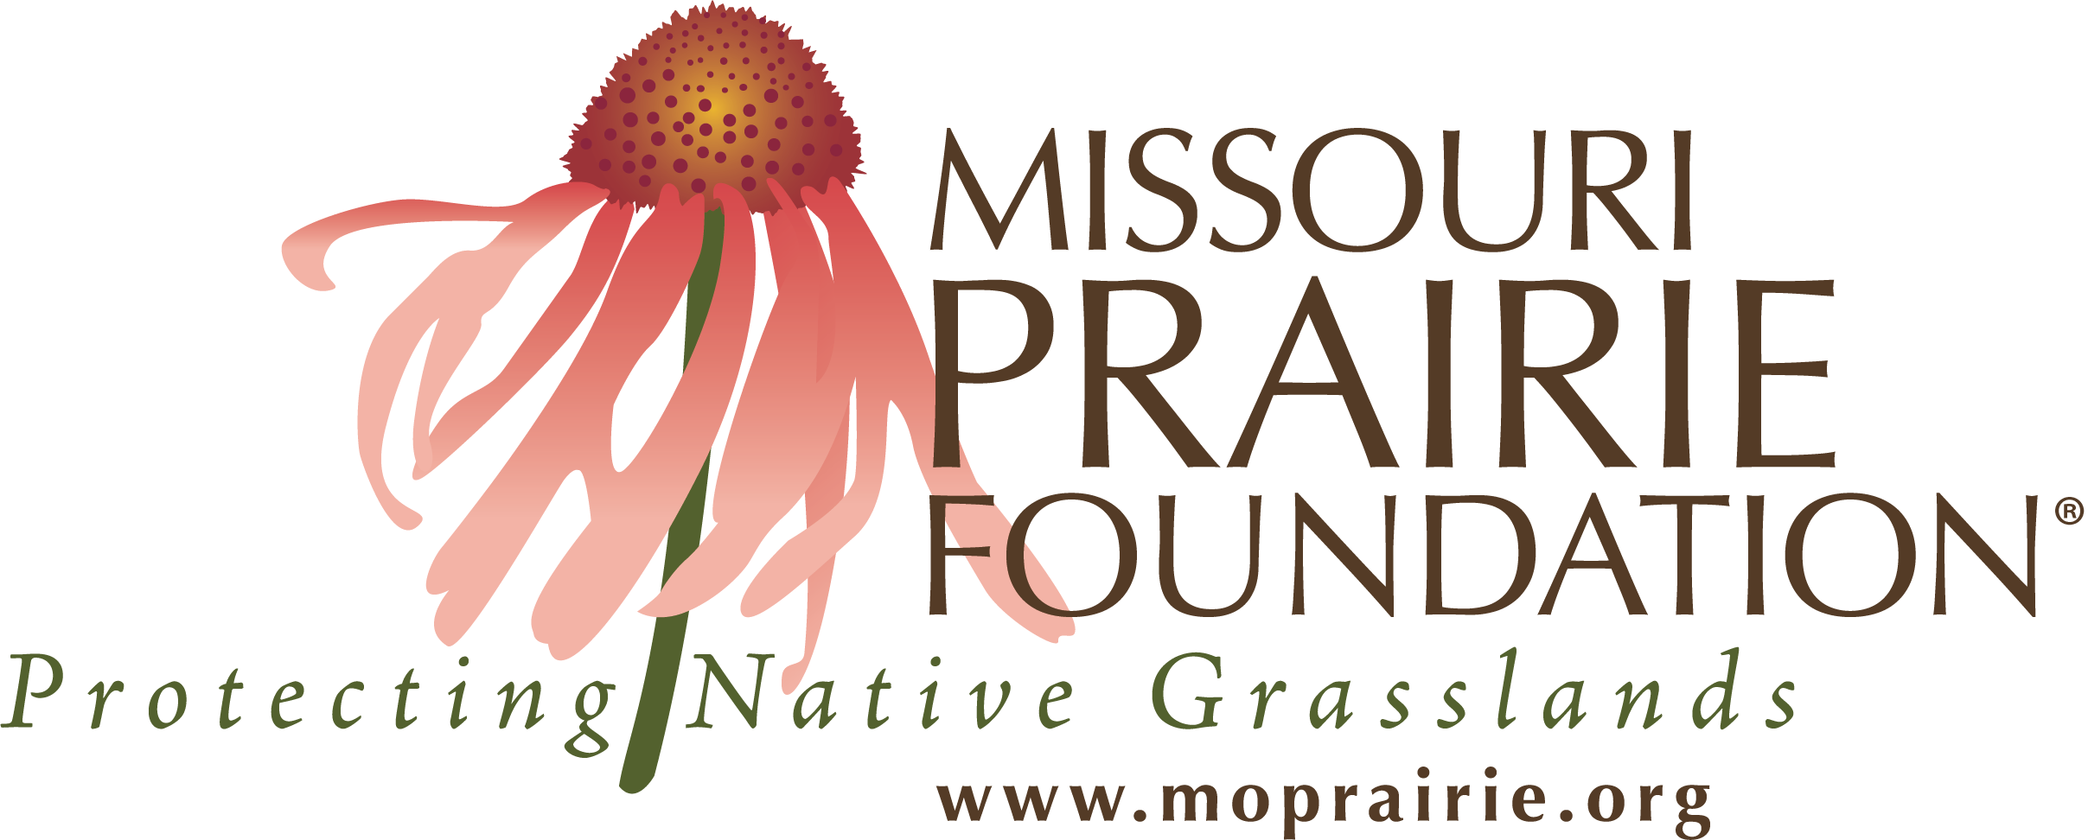 | 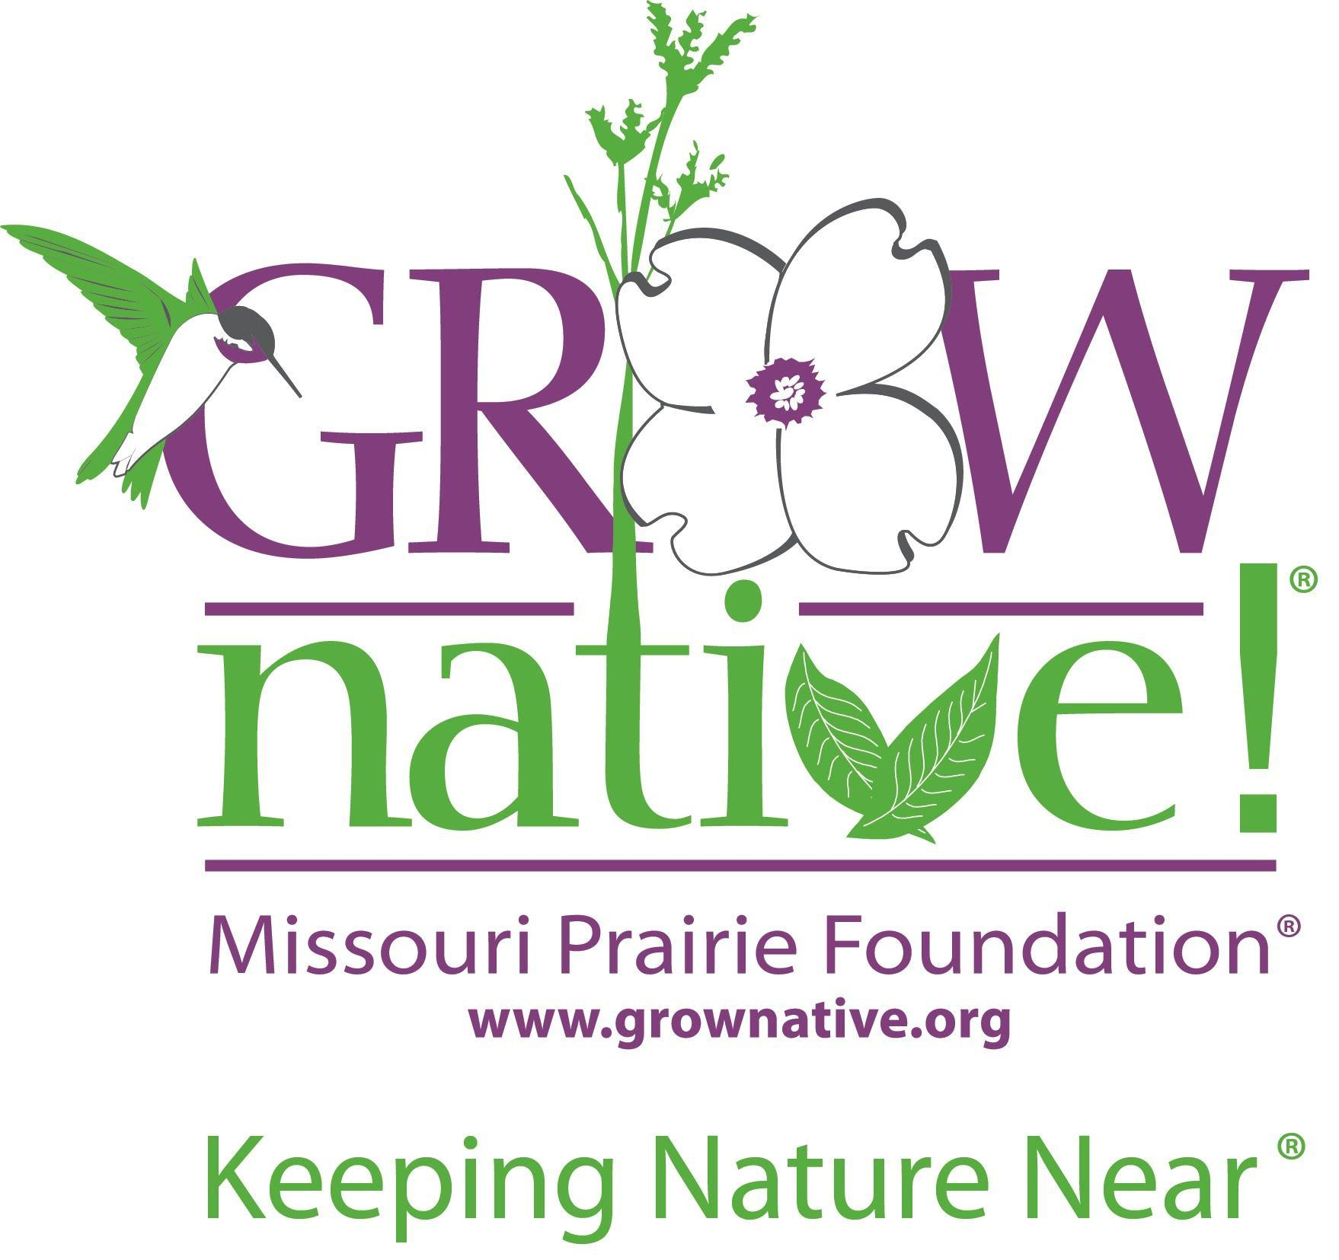

Contact: Brooke Widmar: 888-843-6739

FOR IMMEDIATE RELEASE

Missouri Prairie Foundation & Grow Native! Offer Weekly Webinars & Master Classes in May 2021

The Missouri Prairie Foundation and its Grow Native! native program continue its popular online programming.

Jefferson City, MO (April 30, 2021)—Nearly 7,000 live attendees have enjoyed the online programming offered by the Missouri Prairie Foundation (MPF) and its 21-year-old Grow Native! program from January through April 2021. MPF continues its popular webinar and master class schedule in May.
During these virtual learning opportunities hosted each week at 4:00 p.m., participants can learn from a variety of speakers on topics such as bumble bees, prairie mammals, prairie history, and pollinator gardening.
Speakers will include Katie Lamke, a conservation biologist for the Xerces Society; Doug Helmers, retired USFW private lands coordinator and MPF board member; Dr. Sean Maher, Associate Professor in the Biology Department at Missouri State University; Doug Ladd, retired director of conservation for The Nature Conservancy; and Paula Diaz, with GardeNerd Consultations.
Webinars are free, 30-minute programs, with time for questions after the presentations. Master classes are more specialized, with presenters sharing 50-minutes of material, with time for questions after the presentations. Master classes are free to MPF members and Grow Native! professional members, and $15 for non-members.
Not a member? Join at moprairie.org/membership/ and attend all master class programming as a benefit of membership. Landscape architect continuing education credits are available for master classes and most webinars.
May Webinars and Master Class Schedule:

Wednesday, May 5: MPF Master Class: Bumble Bees of Missouri with Katie Lamke

Wednesday, May 12: MPF Webinar: Small Mammal Ecology in a Fragmented Landscape with Dr. Sean Maher
Thursday, May 19: MPF Webinar: We did This – How Humans Created, Destroyed, and are Resurrecting America’s Tallgrass Prairies with Doug Ladd
Wednesday, May 26: Grow Native! Webinar: 10 Steps to Moving Beyond Monarchs with Paula Diaz

Register online for each webinar and master class, and a Zoom link will be emailed to you the week of the event. Recordings of the programming will be sent to all registrants, the free webinars will be posted publicly at the MPF YouTube Channel.
The nonprofit Missouri Prairie Foundation is a 55-year-old prairie conservation organization and nationally accredited land trust. Grow Native! is MPF’s 21-year-old native plant marketing and education program serving the lower Midwest. For more information about webinars and master classes, the Grow Native! program, or the Missouri Prairie Foundation, call 888-843-6739 or send a message to info@moprairie.org.

