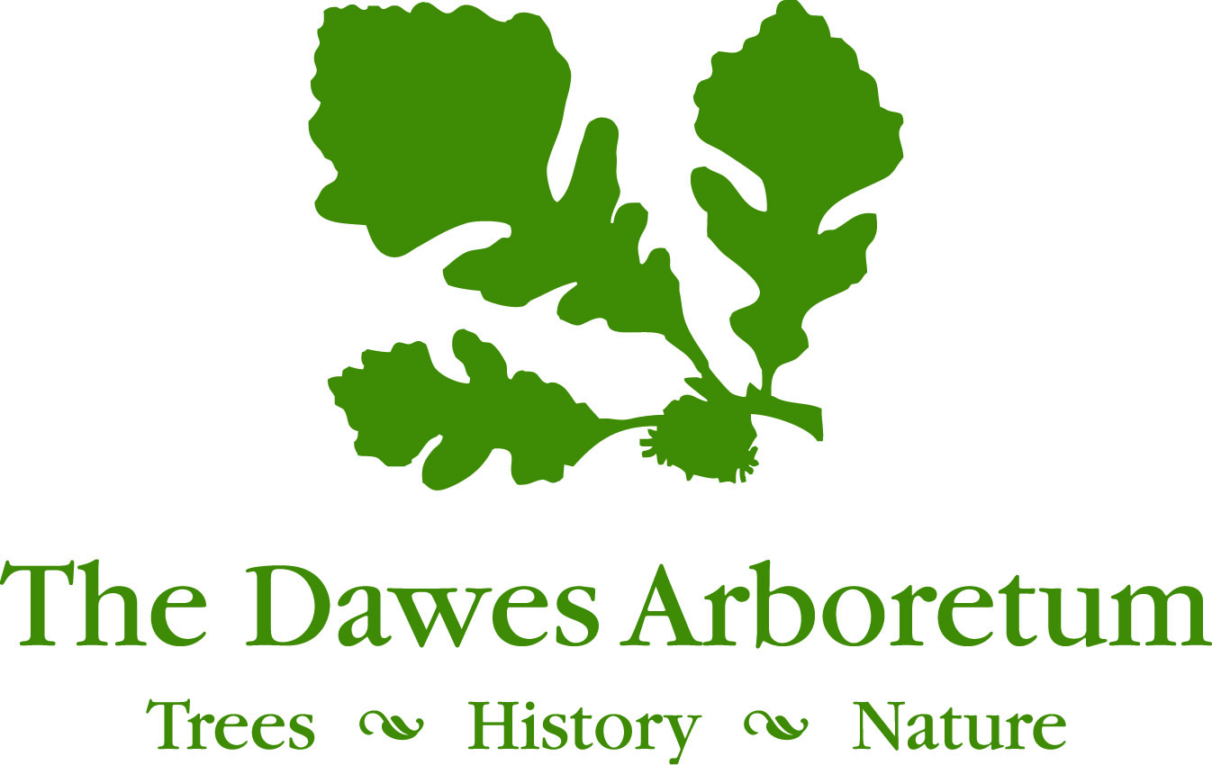

Environmental Professionals Training Program

The Environmental Professionals Training Program is an advanced career training program specifically designed for recent graduates and emerging conservation professionals, seeking direct experience and practical skills to enhance credentials and assist in occupational advancement opportunities.

This program provides specialized knowledge in plant conservation, natural resource management, ecosystem restoration and the curation of plant collections through direct training experiences. Participants gain the skills necessary to demonstrate proficiency in the field by working alongside and networking with fellow conservation professionals in a variety of work environments in order to accelerate learning and increase credentials for job seeking.

Qualifications:
- Degree in Ecology, Horticulture, Botany, Natural Resources or related field
- Good organizational skills and computer proficiency (Windows, Word, Excel, etc.)
- Self-motivation, willingness to learn and eagerness to apply newly acquired skills
- Independent decision making and problem solving ability
- Desire to work outside at any time of year
- Ability to maintain professional, positive communication in person and in writing
- Available on a flexible schedule, including some evenings and weekends
- Possession of a valid motor vehicle operator’s license and a good driving record required
- Successful completion of pre-start background check

Opportunities:
- Learn hands-on ecosystem restoration techniques and natural resource management within wetlands, woodlands, streams, and prairie habitats
- Apply adaptive management through a variety of field research methods
- Utilize GIS applications and photo point documentation for report writing
- Develop skill in greenhouse operation, seed collection, germination and transplanting
- Practice herbarium mounting, specimen accessioning and managing collections records
- Learn native plant identification and invasive species management techniques
- Conduct biodiversity surveys and vegetation monitoring protocols
- Participate in wildlife monitoring projects and nesting structure maintenance
- Present educational programs on project outcomes
- Engage volunteers and organize events

Training & Career Skill Development*:
- Advanced botany and comprehensive vegetation monitoring techniques
- Plot delineation and photo point documentation
- Herbarium vouchering and collections management
- Native plant propagation, nursery management and greenhouse care
- Sustainable landscaping and natural habitat design
- Invasive species identification and management
- Project design and reporting
- ArcGIS software applications and map making
- Grant writing, project management and budgeting
- Reforestation planning and forest management
- Long-term native butterfly population monitoring *
- Citizen science programming, including monarch butterfly rearing and tagging*
- Trail mapping, maintenance and wayfinding strategies
- Stream, pond, and wetland conservation and management
- Sustainable agriculture practices, soil testing and erosion control methods
- Wildlife nesting structure installation, monitoring and maintenance
- Prairie habitat establishment and maintenance
- Prescribed fire management techniques*
- Various field methods for monitoring vegetation and wildlife populations
- Wildlife management and nuisance trapping
- Environmental education, public speaking and visitor engagement
- Licensure as a Commercial Pesticide Applicator (optional)
- Licensure as a Nuisance Wild Animal Control Operator (optional)
- Local conferences, workshops and professional development events, as available

*Please note certain training opportunity are seasonally dependent.

Compensation:
All training and licensure is provided at no cost to participants. The Dawes Arboretum provides on-site housing, all utilities, and covers off-site training registration fees and optional licensures as compensation to participants (equivalent $3,000).
Participants also receive a cash meal stipend ($1,000).
Upon successful completion of the program, participants receive an Arboretum issued certificate of completion and if applicable, letters of recommendation.

Terms:
Start dates are flexible within 1-2 weeks pending acceptance into the program.
WINTER / SPRING: mid-January to early June
SUMMER / FALL: mid-June to early November

Application Deadline:
May 1, 2020 (for Summer/Fall term) and Dec 1, 2020 (for Winter/Spring term)

How to Apply:
Send cover letter, resume and a letter of reference via email:
Shana Byrd, Director of Land Conservation
The Dawes Arboretum, 7770 Jacksontown Road
Newark, OH 43056
Email: sbyrd@dawesarb.org

