Outreach Notice

GS-0440-11/12
GS-0462-08/09/10, Zone Geneticist
Forest Supervisor's Office
Okanogan-Wenatchee National Forest
Wenatchee, Washington

Outreach Response Date: November 17, 2019

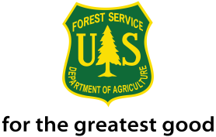
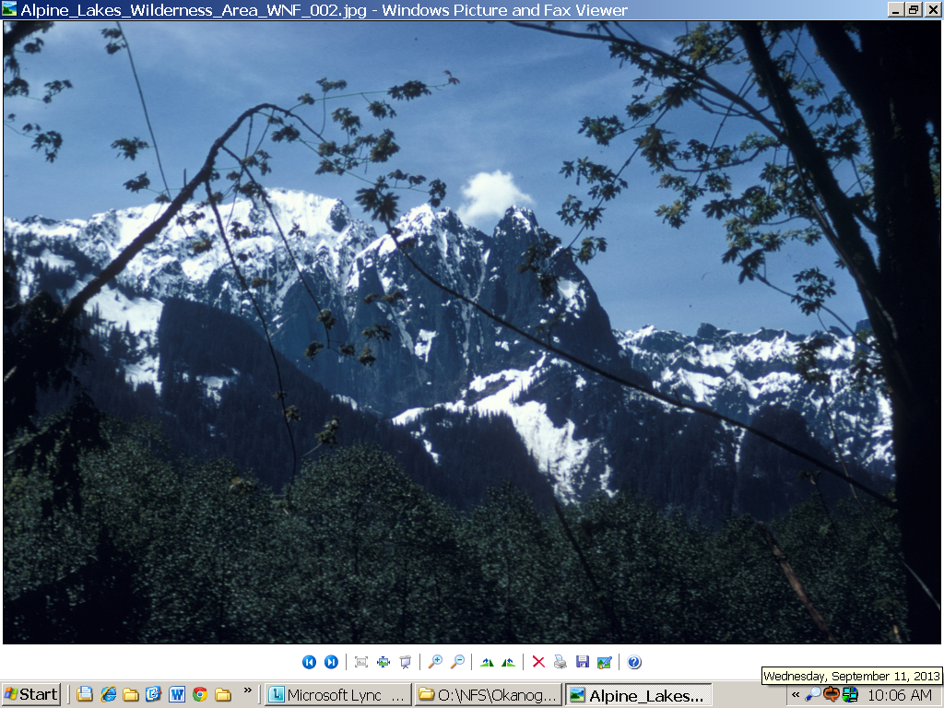About the Position

The Okagogan-Wenatchee National Forest will soon advertise a permanent, full time Zone Geneticist position with a duty station of Wenatchee, Washington.
If interested in the position, please complete the outreach response form at the bottom of this document, attach a resume, and send to Teri Tucker, Resources/Planning Staff Officer, teresa.tucker@usda.gov , by November 17, 2019. This ensures that you will receive notification when the vacancy announcement is posted on http://www.usajobs.opm.gov
The Outreach Notice is also located in the Forest Service Outreach Database at:
https://fsoutreach.gdcii.com?id=9BCC349DD6474434A39EE3879840DFBB

For further information about this position, please contact Vicky Erickson, Regional Geneticist (vicky.erickson@usda.gov, 541-278-3715). For information regarding the Okanogan-Wenatchee National Forest please contact Teri Tucker, Resources/Planning Staff Officer (teresa.tucker@usda.gov, 509-664-9332).

Headquartered in Wenatchee, Washington, the four-million-acre Okanogan-Wenatchee National Forest has seven ranger districts (Chelan, Cle Elum, Entiat, Methow Valley, Naches, Tonasket, and Wenatchee River). These varied and spectacular lands extend along the eastern flank of the Washington Cascade Mountains from the Canadian border to the Yakama Indian Reservation on the south.

A wide variety of ecosystems are present, ranging from lush alpine meadows and forest to dry Ponderosa pine to semi-arid shrub steppe. The rain shadow effect of the Cascade Range on precipitation coming in from the Pacific Ocean strongly influences this pattern. Near the crest as much as 100 inches of precipitation, most in the form of snow, may fall. The eastern foothills and valleys are much more arid and may expect less than ten inches of annual precipitation. Abundant sunshine, clear streams, spectacular scenery, seasonal snow and proximity too many of Washington’s urban areas attract heavy recreation use– consistently in the top ten visited forests in the nation. In addition, the Okanogan-Wenatchee has significant timber, fire, wildlife, fisheries, engineering and minerals programs.

ABOUT THE POSITION
This position is located in the Forest Supervisor’s Office and is a member of the Planning/Resources Group. The incumbent serves as the Zone Geneticist for the Okanogan-Wenatchee, Colville, and Mt. Baker-Snoqualmie National Forests in the state of Washington. The primary responsibility of the position is to provide expertise in genetic conservation, plant material selection and breeding, seed orchard management, and planning/coordinating/recommending forest tree seed and native plant material sources for a diverse array of forest and rangeland re-vegetation activities and objectives. The incumbent works closely with the leadership of the three national forests and the regional office to craft the annual program of work. The work is strongly service-oriented towards applied genetics - both forest trees and non-tree native plant species - and serving the forests of the area. The incumbent collaborates with the regional geneticist and other area geneticists on critical natural resources issues and activities such as maintenance of genetic diversity and plant adaptation, disease and insect resistance, plant material collection and development, seed quality and identity, seed movement, and climate change adaptation. Working with partners, researchers, and other external collaborators to build the knowledge base and capacity of the national forest genetics program is a critical function of the position. The position is supervised by the Okanogan –Wenatchee National Forest Resources/Planning Staff Officer, with a duty station in Wenatchee, WA.

This position:

Works with various specialists and managers across a tri-forest area to effectively deliver applied science and monitoring to help address challenging natural resources questions and issues encountered in multiple-use management of public lands.

Serves as the principal authority on the subject of genetic resource management for the forests within the area of responsibility. Develops methods for incorporating genetic principles, technical guidance, and analysis into resource management planning, programs, and projects.

Collaborates with forest managers and partners in promoting understanding of key genetic and ecological considerations as the three national forests served embark on accelerated landscape restoration of upland and aquatic/riparian ecosystems.

Collaborates with forest resource managers and specialists in determining which plant species and seed sources (including disease resistant western white pine and whitebark pine) are best suited for revegetation, and the quantity of plant materials needed to accomplish planned and unplanned restoration activities in support of forest management plans and programs, and responses to catastrophic disturbances.
- Provides guidance on the best methods for collecting and propagating native species to ensure genetic diversity and adaptation and producing needed supplies of plant materials for current and future revegetation activities.

Directs management of genetic assets (seed orchards, cutting orchards, breeding orchards, clone banks, provenance trials, progeny test sites, plus trees, etc.) to enhance tree health and reproductive capabilities and to protect against fire, insect and disease outbreaks, animal damage and other risks
- Plans and conducts genetic conservation actions and studies of threatened, endangered, and sensitive plant species in support of recovery efforts and protection of species whose persistence may be at risk on Forest Service lands. Develops and implements genetic conservation and monitoring plans for vulnerable species and populations.

Provides professional level support to project development and implementation for terrestrial and aquatic restoration, vegetation management, range management, and other forest projects.

Works closely with silviculture, botany, timber, fuels, fisheries/wildlife biologists, range, engineering, and other disciplines to accomplish Forest priorities in a manner compatible with forest health and restoration.
- Collaborates with the regional geneticist and other area geneticists, silviculturists, botanists, forest health protection specialists, as well as staff at Dorena Genetic Resource Center, Bend Seed Extractory, and federal and private nurseries on issues regarding genetic diversity, plant adaptation, disease and insect resistance, plant material development, seed quality and identity, seed movement, and climate change adaptation.

Develops and conducts training sessions, workshops, and webinars individually or in collaboration with other geneticists and resource specialists. Topics may include seed collection, seedbank management, genetic principles of plant material development, seed orchard management, climate change and seed movement guidance, pollination ecology, etc.
QUALIFICATION REQUIREMENTS:
Genetics, or a curriculum or pattern of training that placed major emphasis on genetics. A minimum of 9 hours of semester coursework in genetics or other coursework with emphasis on genetics is required to qualify for a Geneticist (GS-0440) position. Graduate study in related fields such as botany, biology, agronomy, horticulture, microbiology, plant pathology, chemistry, molecular and cellular biology, and physiology that involved cross-training in genetics is qualifying, provided it placed sufficient emphasis on genetics. Undergraduate and graduate courses dealing with genetics, some phase of genetics, or specific techniques that are applied in genetics work are acceptable. This includes courses in genetics, plant genetics, molecular and cellular biology, mathematics and statistics (as they apply to genetics), and population dynamics. Course work consisting of an appropriate combination of basic courses in genetics and cytology or statistics are also acceptable. The following link provides more information on how to qualify for the position: https://www.opm.gov/policy-data-oversight/classification-qualifications/general-schedule-qualification-standards/0400/genetics-series-0440/
Those who are interested must meet the qualification requirements for the GS-0440 series that are covered by the U. S. Office of Personnel Management (OPM) Qualification Standards for General Schedule Positions – Professional and Scientific Positions. The OPM Qualification Standards Handbook Manual is available for review at any federal personnel office or on the Internet at: http://www.opm.gov/policy-data-oversight/classification-qualifications/general-schedule-qualification-standards/#url=Group-Standards

The Forest: The Okanogan-Wenatchee National Forest covers approximately 4 million acres. Summers are hot and dry, and winters are famous for brilliant clear skies and plenty of snow. The 1,706,000-acre Okanogan portion of the forest has two distinct sides, east and west, referred to as the Methow and Okanogan valleys. Each area is a destination in itself and together they offer days and days of things to do and see. The Okanogan portion of the forest includes the Pasayten and Lake Chelan-Sawtooth Wildernesses and is home to the North Cascade Smokejumper Base.
The 2.2 million acre Wenatchee portion of the forest extends about 135 miles along the east side of the Cascade crest from Lake Chelan in the north to the Yakima Indian Reservation in the south. Vegetation varies from grasslands and sage brush to beautiful Ponderosa Pine and Douglas-fir with alpine fir in the higher elevations. Nearly 40% of the Wenatchee’s forest land in designated as wilderness area: The Lake Chelan-Sawtooth, Glacier Peak, Henry M. Jackson, Alpine Lakes, William O. Douglas, Norse Peak and the Goat Rocks.

Recreation: Recreational opportunities abound in the area. Three major ski areas are found within 60 minutes of Wenatchee as well as several small local ski areas. There are various Cross Country ski trails and opportunities for heli-skiing. The forests trail and road systems allow for snowmobiling, horse back riding, mountain biking, trailbike riding and snowshoeing. Wildlife habitat provides a wide array of hunting opportunities from elk, deer and bear to pheasant, chukkar and grouse. Streams, ponds, rivers and lakes harbor several varieties of trout and furnish water sport enthusiasts a fanfare of ventures. Whether it’s scenic vistas, para-gliding, rock climbing, kyacking or camping activities you enjoy, the Okanogan-Wenatchee provides abundant opportunities.

The Community: The Wenatchee Valley is nestled on the shores of the mighty Columbia River. It is located in Central Washington just 100 miles southeast of Seattle and 165 miles west of Spokane. The Greater Wenatchee Area has approximately 48,000 residents who enjoy living in a region with four distinct seasons. Housing cost and other local information can be found at http://www.city-data.com/city/Wenatchee-Washington.html. The schools, services, museums, health and athletic clubs, hospitals and airports are only part of what makes Wenatchee one of the most desirable places to live, work and play.

Education: The community’s higher education needs are met by Wenatchee Valley College, a comprehensive community college featuring two-year degree programs and transfer programs in conjunction with state four-year institutions including Eastern Washington University, Central Washington University and Washington State University. The Wenatchee and Eastmont school districts serve 9,000 students in 11 elementary schools, two special education schools, four middle and junior high schools, an alternative high school, and two senior high schools, one AAA and one AAAA. In addition to public education, three private religious schools, a Head Start program, and numerous pre-schools and kindergartens serve the area. All the school districts in Wenatchee are proud to offer students ample opportunity for academic and athletic excellence.

Health Care: Central Washington Hospital (located in Wenatchee) is the major health care facility in the region. Central Washington Hospital is more than a community hospital. It is the major medical facility and referral center for North Central Washington. Central Washington Hospital provides quality medical care to residents of North Central Washington - right here at home. Like local schools, businesses and churches, a community hospital is a key resource that enhances the quality of life where we live and work.
Services include inpatient and outpatient surgery, cardiac program, coronary and intensive care, respiratory care, oncology, dialysis, neonatal nursery, home health and hospice, regional trauma emergency department, skilled nursing and rehabilitative services such as cardio-pulmonary, physical, speech, and occupational therapies.
Wenatchee Valley Medical Center, established in 1940, is a large rural healthcare delivery system in multi-specialty group practice with a regional focus and a commitment to serve patient needs by providing the highest quality healthcare and services in an atmosphere of concern and caring. With over 170 physicians providing comprehensive medical and ancillary services, we are the second largest multi-specialty clinic in the Pacific Northwest. Our physicians provide primary care to area residents and also draw patients from throughout the region for specialty care.
Over 60 dentists, hygienists, orthodontists, and dental laboratories serve the Wenatchee area. Wenatchee also has a life flight helicopter stationed at Central Washington Hospital and Executive Flight possesses three jet air ambulances stationed at Pangborn Airport in East Wenatchee.

“The U.S. Department of Agriculture (USDA) prohibits discrimination in all its programs and activities on the basis of race, color, national origin, age, disability, and where applicable, sex, marital status, familial status, parental status, religion, sexual orientation, genetic information, political beliefs, reprisal, or because all or part of an individual’s income is derived from any public assistance program. (Not all prohibited bases apply to all programs.) Persons with disabilities who require alternative means for communication of program information (Braille, large print, audiotape, etc.) should contact USDA’s TARGET Center at (202)720-2600 (voice and TDD). To file a complaint of discrimination, write to USDA, Director, Office of Civil Rights, 1400 Independence Avenue, S.W., Washington, DC 20250-9410, or call (800) 795-3272 (voice) or (202) 720-6382 (TDD). USDA is an equal opportunity provider and employer.”

OUTREACH RESPONSE FORM

Please respond by November 17, 2019.

If you are interested in applying for this position and want to receive updates of the position’s status, please complete the attached outreach form and send electronically to Teri Tucker, Natural Resources & Planning Staff Officer, at teresa.tucker@usda.gov or 509-664-9332.

I am interested in the following permanent position:

Position Title/Series/Grade: |  | Area Geneticist, GS-0440-11/12
Location: | Region 6, Okanogan-Wenatchee National Forest, Wenatchee, WA

Name:
Address:
Email Address:
Phone:
If current federal employee:
Current title/series/grade:
Current agency and location:
Type of Appointment:
Permanent |  |  | Term |  |  | Temporary
If not a current permanent employee are you eligible for appointment under any of the following special authorities?

- Persons with Disabilities ____
- Former Peace Corps Volunteer ____
- Public Lands Corps Program ____
- Pathways Internship Program ____
- Recent Graduates Program ____
- Veterans Recruitment Act ____
- Disabled Veteran (30% Compensable) ____
- Veterans Employment Opportunities Act of 1988 ____

How did you hear about this outreach? _____________________________________

