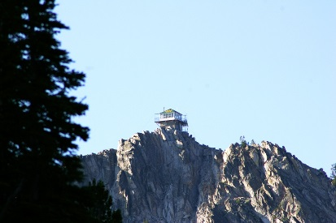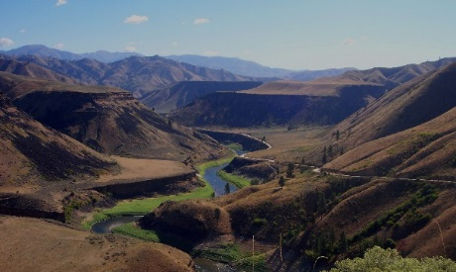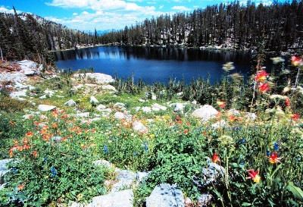

Boise National Forest
  - South Zone Botanist GS-0430-9/11
  - Mountain Home, ID

The Boise National Forest is conducting outreach for our South Zone Botanist (GS-0430-9/11) located in Mountain Home, Idaho.
Vacancy announcement 20-R4SVSEP-0402-631134G-GS (Merit; for status applicants only) and 20-R4SVSEP-0402-631134DP-GS (DEMO; open to the public) is open on USAJOBS for the position: Botanist, GS-0430-9/11, located on the Boise National Forest; Mountain Home Ranger District, Mountain Home, Idaho.
The announcements opens Tuesday October 22, 2019. The DEMO announcements closes on Monday, October 28, 2019 and the Merit closes on Monday, November 4, 2019.

https://fsoutreach.gdcii.com/?id=176D8CB8774E466A89649C69B0EE50C8
Position Information – The incumbent serves as a Botanist providing technical expert assistance to the South Zone in matters dealing with threatened, endangered and sensitive plant species and plant community and vegetation management. Serves as a botanical expert when working on interdisciplinary teams interpreting complex botanical situations involving specialists from several management groups and agencies. As a member of both district management teams, the incumbent will occasionally serve as acting district ranger.
The Forest: The Boise National Forest’s vast landscape spans over 2.5 million acres of diverse forest and grassland. Located northeast of Idaho’s capital city of Boise, recreationists can explore the North Fork Payette River Canyon at 2,800 feet in elevation to the nearly 10,000 foot Peak of Trinity Mountain. Whether you choose to explore more than 500 trails, or cool off in one of over 250 lakes and reservoirs, the Boise National Forest is truly an outdoor enthusiast’s dream!
South Zone: The South Zone of the Boise National Forest includes the Mountain Home and Idaho City Ranger Districts.
The Mountain Home Ranger District is the largest and southernmost district on the Boise National Forest at 650,000 acres in size. It is located in close proximity to Boise, Idaho and includes administration of Capitol City front-range lands. The District has a robust program of work that covers vegetation management, recreation, range, wildlife, fisheries, watershed, fire and fuels, noxious weeds, minerals, and special uses. The scenery is very diverse and mountainous and transitions from desert at the lower elevations, through ponderosa pine and Douglas-fir forests, to high alpine (9700 feet). The district includes a ski area, three major reservoirs, two scenic river corridors and numerous motorized and non-motorized trail systems.
The Idaho City Ranger District is just over 400,000 acres in size, ranging from open foothills along the Payette River on the western border of the District to the beautiful and famous Sawtooth Mountains on the eastern portion. Elevations range from 3200 to 8800 feet. The District receives high visibility due to its close proximity to Boise. Several beautiful pristine rivers flow through the District offering some of the best strongholds of bull trout habitat in South West Idaho. Trails for hiking, horseback riding, mountain biking, and motorized activities are abundant and provide for numerous opportunities in the mild season. With relatively heavy snows and long winters, the District is a destination for many cross country skiers and snowmobilers with abundant ski and snowmobile trails.
Community Information
Mountain Home, Idaho: Mountain Home is located between the Danskin and Owyhee Mountains in southwest Idaho. It has a population of over 15,000 and is the county seat for Elmore County. The Mountain Home Air Force Base, located 10 miles west of town, contributes considerably to the diversity of the community and its economy. Mountain Home has a strong sense of family values and community, as evidenced in our local events, including Air Force Appreciation Day, one of Idaho's largest parades. Mountain Home is a rapidly growing community that maintains a small town feel.
The Snake River and the remote and secluded Bruneau Canyon area are located south of Mountain Home. Visitors and residents alike enjoy the abundant local recreational activities including hiking, camping, fishing, backpacking, motorcycle/snowmobile trails and hunting to name just a few. The Mountain Home School District is located in Mountain Home and includes 9 schools that serve 4,127 students in grades PK through 12. Mountain Home is approximately a 45 minute drive from the state capitol of Boise, Idaho.
There is no government housing available in Mountain Home. An average 3 bedroom 2 bath single family home sells for around $200,000. Numerous rental apartments and homes are available as well.
The climate is mild in Mountain Home with average high temperatures in the mid 90’s in the summer months and 40’s in the winter. Lows average from high 50’s in the summer to the low 20’s in winter. Annual precipitation in Mountain Home averages about 10 inches/year with most occurring from late fall to spring. Total annual snowfall averages about 11 inches with most occurring in December and January. Elmore County averages 80 to 85 percent sunny days during the months of July and August. On the average there are 55 days a year that are 90 degrees (F) or above.
For more information: Mountain Home Chamber of Commerce: http://www.mountainhomechamber.com/
Boise, Idaho: Boise is about 45 minutes from either Idaho City or Mountain Home and offers the services and amenities of the largest city in the State of Idaho. Many employees commute from Boise daily. The Boise metropolitan area is commonly referred to as the “Treasure Valley” with a population of roughly 600,000 people. An international airport, shopping, colleges, and universities, and a variety of cultural and sporting events are readily accessible and available. The treasure valley has numerous grade schools, junior high schools, high schools and both private and public colleges and universities.
Several large regional, national, and international companies are headquartered in the “Treasure Valley”, including Morrison-Knudsen, Simplot, Boise Cascade, Micron Technologies, and Hewlett-Packard. Two large medical regional centers (St. Lukes and St. Alphonsus) are also located here.
There is no government housing available in Boise. An average 3 bedroom 2 bath single family home sells for around $300,000. Numerous rental apartments and homes are available as well.
For more information: Boise Chamber of Commerce: http://www.boisechamber.org/
Idaho City, Idaho: About 40 miles northeast of Boise, historic Idaho City, once the largest city in the Northwest, remains a living representation of the Boise Basin Gold Rush. The town, which survived disastrous fires in the 1860s, has outlived the gold rush, and successfully bridges the past and present. Hiking, camping, snowshoeing and Nordic skiing are all nearby, and yurt camping in the winter months is very popular. Cougar, bear, coyotes and wildlife abound in the forests that punctuate the community. Idaho City has an elementary and high school located conveniently in town.
Government Housing is available for rent, as well as local apartments and houses for sale. An average 3 bedroom 2 bath single family home sells for around $250,000.
The Climate is very mild in Idaho City. Average Highs range from 87 in the summer to 36 in the winter and average Lows range from 45 in the summer and 13 in the winter.
The Idaho City area has very limited cell phone coverage.
For more information about Idaho City: Idaho City Chamber of Commerce http://www.idahocitychamber.com/
How to respond - If you have questions about the position, please contact Stephaney Kerley, Mountain Home District Ranger, skerley@fs.fed.us at (208) 587-7830. If you are interested in applying for this position please respond in the Forest Service Outreach Database Outreach Database.

