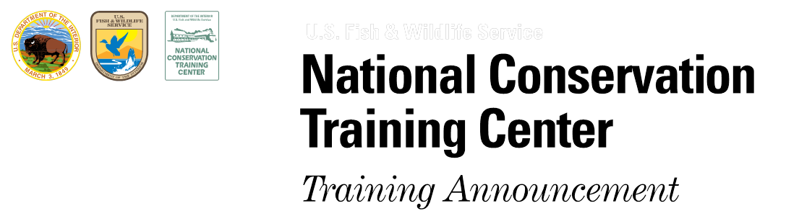

Forest Ecology and Management Webinar Series
Date
Thursday August 23rd, 2018

Time
1:00 – 2:00 p.m. EDT

Location
Please use both the webinar link and conference call information to see and hear the presentation.

Who Should Attend
Ecologists, foresters, wildlife biologists, land owners and resource managers.

To Join the Webinar
At least 10 minutes prior to webinar:
- Go to:
http://www.mymeetings.com/nc/join.php?i=742287910&p=2222&t=c

(we recommend you use your Mircosoft Explorer browser for MyMeetings)
- Select “Enter as Guest” (no need to download)
- Type in your first and last name and email.
- Check the privacy statement box and hit “proceed”
- For audio use:
Conference Call Line: 1-888-603-6971
Passcode: 6962258

Sponsor and Contact information
”The Forest Ecology and Management Webinar Series” is sponsored by the U.S. Fish and Wildlife Service’s Forest Ecology Working Group (FEWG). The FEWG is a forest ecology based community of practice for individuals to share forest ecosystem expertise and information to benefit multidisciplinary projects and to build capacity for understanding forest ecosystems.

For more information about the
Forest Ecology Working Group contact:
Jeff_Horan@fws.gov
or 413-253-8228
“Ecological Site Descriptions - A helpful tool for managing healthy and diverse ecosystems”
Presenters:
Thomas LaPointe
Forest Ecologist
USDOI Fish and Wildlife Service, Umbagog NWR, Errol, NH
Jamin Johanson
Ecological Site Specialist
USDA Natural Resource Conservation Service, Dover-Foxcroft, Maine

Webinar Description
Ecological Site Descriptions (ESDs) are being developed by USDA Natural Resource Conservation Service (NRCS) for all lands within the U.S. ESDs are a repository of information designed to help landowners and resource managers make informed decisions about managing land within an ecological context. They describe land with similar physical and biological characteristics at scales suitable for natural resource planning and management. National Wildlife Refuges in the northeastern United States are working collaboratively with NRCS to develop ESDs and are starting to use them to assess biological diversity, guide management actions, and make informed decisions about how refuge lands can contribute to landscape conservation goals. At Umbagog NWR, forest management is designed to restore, rehabilitate, and maintain native plants on appropriate ecological sites.

Presentation Objectives:
(1) Introduce Ecological Site Descriptions, their purpose, the scope of the NRCS program, and collaborative partnerships in the northeastern US Forests.
(2) Describe Ecological Site concepts, definitions, and scales.
(3) Describe how ESDs are developed and the information they contain.
(4) Describe how ESDs are useful to improve management, how to access them, and how to assist in developing them for your region.
