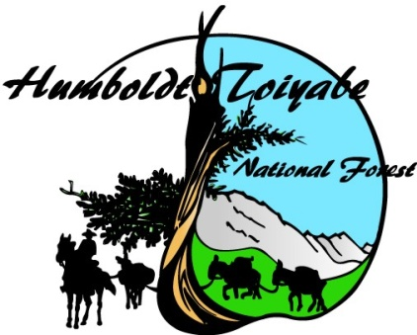
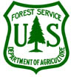
OUTREACH NOTICE

USDA FOREST SERVICE
INTERMOUNTAIN REGION, R4
HUMBOLDT-TOIYABE NATIONAL FOREST
Santa Rosa Ranger District
Zone Botanist GS-0430-7/9/11

*PLEASE STATE DUTY STATION PREFERENCE ON THE RESPONSE FORM*

The Humboldt-Toiyabe (H-T) National Forest, Santa Rosa Ranger District will soon be advertising to fill a Zone Botanist position GS-0430-07/09/11 with a target series and grade of GS-0430-11

About the Position:

Series/Grade: GS-0430-07/09/11
Title: Zone Botanist
Duty Station: Winnemucca, Nevada with possible alternative locations in Elko or Wells.
Tour of Duty: Permanent - Full Time
Housing: Not available

About the Botanist Positions:

The Zone Botanist is responsible for developing, planning, organizing, and executing the botany program and supporting the invasive species program for the Northeast Zone (Santa Rosa, Mountain City/Jarbidge/Ruby Mountains Ranger Districts). This region encompasses a variety of plant communities ranging from desert biomes to subalpine habitats and is home to several rare and endemic plant species.

Duties:
Serves as a Botanist providing technical expert assistance to the unit in matters dealing with threatened, endangered and sensitive plant species and plant community and vegetation management. Is responsible for the identification, management and plant ecology. Ensures consistency throughout the unit in developing and implementing programs to manage and protect these plants.

This position works with other departments on the district and the Forest, and is expected to work in a team environment as a botanical expert interpreting complex botanical situations. This position also works with other federal and state agencies in developing sensitive plant lists and plant species management guidelines for plants found on the unit and conducts training in habitat analysis, plant identification, and documentation procedures for threatened, endangered, and sensitive plant species in accordance with forest management plans and objectives. Maintains a current inventory of all known and proposed endangered, threatened, and sensitive species plant occurrence records.

Monitors effects of Forest Plan implementation on plant communities and interprets trends where management emphasis changes, including fire and grazing programs. Prepares botanical reports, biological evaluations, and assessments to provide input for environmental assessments or draft and final environmental impact statements for the unit. Coordinates with academic institutions regarding specific research and surveys that are periodically conducted on the unit. Attends seminars and meetings and reviews publications and documents to keep informed on status of threatened, endangered and sensitive plants. Prepares statistical and narrative reports, correspondence and briefings as required.

Reviews environmental assessments and environmental impact statements and makes recommendations to ensure that botanical resources and ecosystem integrity are adequately addressed and considered. Maintains communication with, and exchanges sensitive plant and native re-vegetation program information with, other botanists, ecologists, and horticulturists associated with the Forest Service, other Federal and State programs, the scientific community, arboretums, and botanical gardens.

Makes on-the-ground investigations of complex ecological and botanical conditions of the effects of specific activities on the long-term survival of rare plant species, providing recommendations for action in specific cases.

About the Humboldt-Toiyabe National Forest:

At over 6.3 million acres, the Humboldt-Toiyabe National Forest is the largest National Forest in the contiguous United States. The Forest spans the entire state of Nevada, plus an additional one million acres in Eastern California, along the Eastern Sierra Front. The Forest consists of four distinct geographic areas, the Sierra Nevada, Central Nevada, Northeastern Nevada, and the Spring Mountains out of Las Vegas.

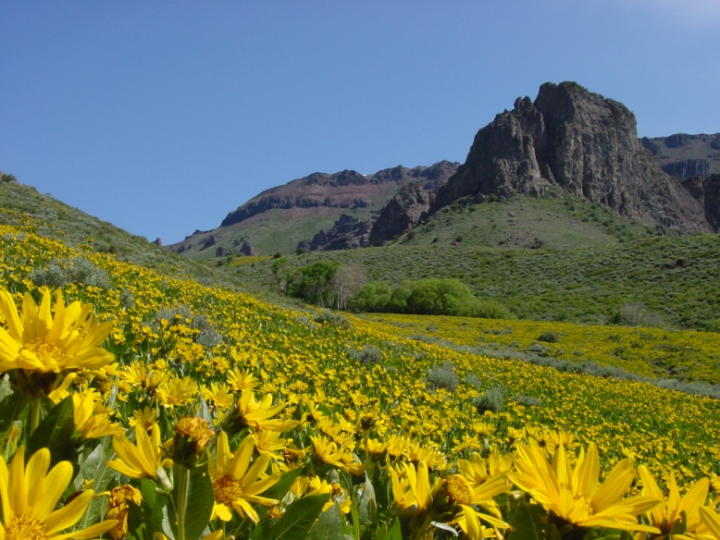
Santa Rosa Ranger District:
The district is one of seven districts on the Humboldt-Toiyabe. The District is located in north central Nevada and is part of the Great Basin ecosystem. The District encompasses 290,000 acres and spans the Santa Rosa Mountain Range bordering Oregon to the north. The landscape is comprised of mountains and plateaus, with elevations ranging from 5,000 feet to 9,700 feet composed of sagebrush, aspen, mountain mahogany, and limber pine. The District includes a congressionally designated Wilderness Area.

Winnemucca Community Information:
The District office is located in Winnemucca, NV, a town of about 10,000 residents, located off I-80, 2 1/2 hours east from Reno, NV. Housing in Winnemucca area is limited. Rentals range from $700 to $1400+ per month. A typical 3 bed/2 bath single family home in area costs anywhere from $150,000-$350,000+.
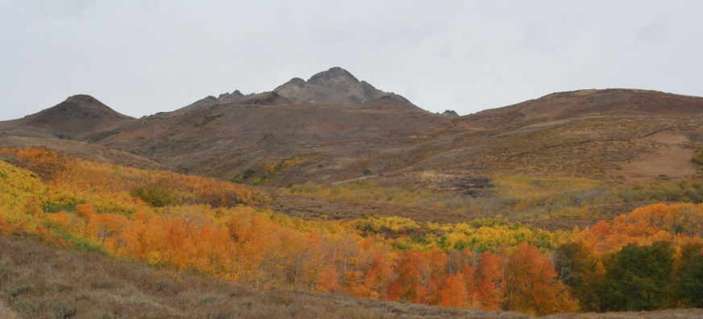
Winnemucca has 3 K-4 elementary schools, 1 middle school, 1 junior high and 1 high school, and a branch of Great Basin College. Winnemucca supports a full service hospital/ambulance corp., several doctors, optometrists, dentists, and Life-Flight services. Churches representing several denominations can be found within the community. Winnemucca has a convention center, indoor events center, museum, swimming pools (one indoor pool), tennis courts, sports complex with four baseball/softball fields, County Library, 9-hole golf course, bowling alley, a movie theater, many mountain bike trails, over 30 restaurants, five casinos, art gallery that features local artists’ work. There is a wide variety of shopping amenities. Hunting, fishing, rock hounding, photography, horseback riding, and boating are popular activities in the area. In addition to the I-80 transportation corridor that connects to the Reno/Tahoe International Airport, Amtrak’s California Zephyr also serves Winnemucca with its local depot that offers daily trips with stops between San Francisco and Chicago. Greyhound Bus rounds out the interstate transportation options from its depot located downtown. Winnemucca is supported by a municipal airport with daily charter flights available.

Annual precipitation in Winnemucca averages 7 inches/year. Summer highs in Winnemucca can exceed 100˚ (F), but average in the 90’s. In winter, low temperatures can reach below zero, but average in the 20’s.

Additional information is available at: https://www.humboldtcountychamber.com/

CONTACTS

For Additional information about the position, the community, or assistance working through the application process please contact:

Joe Garrotto District Ranger, Santa Rosa Ranger District (775) 623-5025 x 115, or email: jgarrotto@fs.fed.us

For additional Forest and District information, check out the H-T website…
http://www.fs.usda.gov/htnf/

Vacancy Announcement

The vacancy announcement for this position will be posted on the U.S. Government's official website for employment opportunities, www.usajobs.gov

The Mountain City, Ruby Mountains, and Jarbidge Ranger District:

Mining, grazing, recreation and fire / fuels are major program areas.

The Mountain City unit lies north of Elko and southeast of Owyhee on State Highway 225, and follows the Independence Mountains north to the Idaho state line. The District is approximately 450,000 acres. Elevations range from 4,600 to 10,439 feet. This is high desert country, dominated by sagebrush at lower elevations and mountain shrubs, aspen and some fir. Sage grouse, mule deer, pronghorn antelope, and Lahontan cutthroat trout are some of the major fish and wildlife species.

The Jarbidge unit offers 243,907 acres of relatively undiscovered recreation opportunities. A view from the north of the Jarbidge Mountains provides the best glimpse of the contrast between basin and range; the Jarbidge Mountains rise abruptly to 10,000 feet out of the 6000 foot Snake River Plains. Snow accumulation averages of about 100 inches, and average temperatures lows of 15°F and highs of 40°F in the winter and lows of 40°F and highs of 80°F in summer months. Vegetative types in the Jarbidge range from sagebrush flats to glaciated alpine basins, subalpine fir, limber pine and white bark pine, aspen groves, and big cottonwoods. Rocky Mountain juniper trees dot the lower-elevation slopes.
The Ruby Mountains unit is made up of the East Humboldt and Ruby Mountain Ranges. The district covers about 450,000 acres with elevations ranging from 6,000 feet to 11,387 feet. The district is characterized by rocky peaks, cirque basins, high glacier-formed lakes, rolling sage/grass hills and step narrow canyons. Yearly snowfall averages about 8-10 feet. Average low temperatures of 15°F in in the winter and lows of 45°F to highs of 80°F in the summer.
Community Information for Elko and Wells:

Elko is located in north eastern Nevada, 230 miles west of Salt Lake, Utah, 295 miles northeast of Reno, Nevada and 250 miles south of Boise, Idaho. The county seat of Elko is a thriving community of approximately 21,000 residents with an additional 15,000 living in the immediate area of Spring Creek who enjoy living in a region with four distinct seasons. The community of Wells is located approximately 51 miles east of Elko on Interstate 80. The town is a traditional ranching community of 1300 people.

Recreation:
Outstanding wildlife habitat provides a wide array of big game hunting opportunity for elk, deer, antelope, big horn sheep, mountain goats, with upland game birds and waterfowl for the bird hunter. Numerous streams, ponds, rivers, lakes and reservoirs harbor several species of trout, bass, and other types of fish. Whether it’s scenic vistas, camping, hiking, fishing, boating, mountain biking or four-wheel driving in the summer to hunting, snowmobiling, ice fishing, or heli-skiing in the fall and winter, Elko County and its large expanses of public lands provides abundant opportunities for the outdoor lover.

Housing:
Housing costs in Elko average $200,000, while the average rental cost is $1000 per month (2 bedroom/ 2 bath). Housing costs in Wells average $170,000, while the average rental cost is $500 per month (2 bedroom / 2 bath).

Health Care: Northeastern Nevada Regional Hospital (located in Elko) is the major health care facility in the region. The 75 private patient room hospital opened in 2001 and represents state of the art technology. Elko also has as Summit Air Emergency Helicopter stationed at Elko Regional Airport and fixed wing medical tranportation.

Education: The community’s higher education needs are met by Great Basin College, a comprehensive community college featuring both two and four-year degree programs and transfer programs in conjunction with the University of Nevada Reno and University of Nevada Las Vegas. The Elko County School District serves 7160 students in 7 elementary schools, three middle and junior high schools, and two senior high schools located in Elko and Spring Creek. The community of Wells has an elementary school, junior high, and high school.

For additional information on Elko, visit their website at www.elkonevada.com.

For additional Forest information, check out the H-T website… http://www.fs.fed.us/htnf/

OUTREACH NOTICE FORM
Zone Botanist

Humboldt-Toiyabe National Forest

Winnemucca, Nevada

GS-0430-07/09/11

Email completed Outreach Notice Form to: Joe Garrotto District Ranger, at jgarrotto@fs.fed.us. Please reply by August 15, 2018

Note: Responding to the outreach is not required to apply for the Vacancy.

NAME:

EMAIL ADDRESS:

MAILING ADDRESS:

TELEPHONE NUMBER:

AGENCY EMPLOYED WITH: USFS BLM OTHER

TYPE OF APPOINTMENT: __ PERMANENT ____TEMPORARY _____TERM
VRA PWD OTHER

CURRENT REGION/FOREST/DISTRICT:
CURRENT SERIES AND GRADE:
CURRENT POSITION TITLE:

PLEASE BRIEFLY DESCRIBE YOUR QUALIFICATIONS/INTEREST FOR THIS POSITION;

PLEASE INDICATE PREFERENCE OF DUTY STATION: ___Winnemucca ___Elko ___Wells

IF NOT A CURRENT PERMANENT (CAREER OR CAREER CONDITIONAL) EMPLOYEE, ARE YOU ELIGIBLE TO BE HIRED UNDER ANY OF THE FOLLOWING SPECIAL AUTHORITIES:

______ PERSON WITH DISABILITIES
______ DISABLED VETERANS W/30% COMPENSABLE DISABILITY
______ VETERANS EMPLOYMENT OPPORTUNITIES ACT OF 1998
______ FORMER PEACE CORPS VOLUNTEER
______ OTHER

