National Seed Strategy 2016 Annual Report

USDA Forest Service Native Plant Material Program

The Forest Service is one of twelve Federal Agencies working together through the Plant Conservation Alliance (PCA) to implement the National Seed Strategy for Rehabilitation and Restoration (Strategy). During Fiscal Year 2016 the Forest Service (FS) implemented various projects across the nation in support of the Strategy.

# US Forest Service Northern Region

Seed zones are under development in the Northern Region for 4 species including 2 pollinator friendly species. Bluebunch wheatgrass seed is available for Forest and grassland use. A common garden study was established for Sandberg’s bluegrass. There are 13 species being tested for delivery to specific ranges using genetic and morphological traits.

The Northern and the Intermountain regions are working together to continue to implement their partnership with the Western Federal Lands Highway Division of the Federal Highways Administration. The agencies provide native plant materials for roadside restoration. The Northern and the Intermountain regions also work together to increase Aspen fleabane (*Erigeron speciosus)* for sage-grouse habitat improvement projects.

Coeur d’Alene Nursery activities in 2016 include Native plant production (container) –More than 72,000 containers were distributed to Region 1, 2, 4 and 6 and to Montana BLM. There were 66 native plant species including shrubs, forbs, grasses and grass-like plants. These include pollinator friendly plants as well as riparian and upland plants. Native plant production (seed) – There are more than 40 grass and forb species in bulk seed production. Many are pollinator friendly forbs such as Canada goldenrod (*Solidago canadensis*) and silverleaf phacelia (*Phacelia hastata*). New plots were established to increase production. Additions includedWestern showy aster (*Aster conspicuus*). Coeur d’Alene Nursery also provides storage for native grass seed until ready for use by Forests and Grasslands.

# US Forest Service Rocky Mountain Region

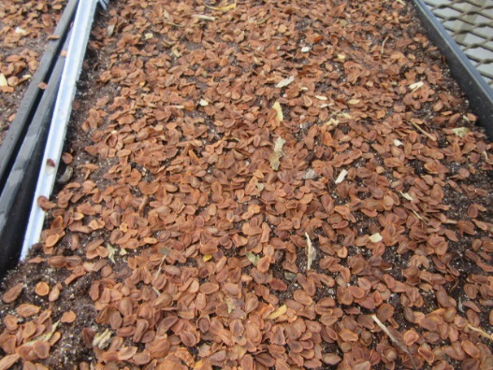The Bessey Nursery is a part of the Nebraska National Forests and National Grasslands in the Rocky Mountain Region. As a part of building a post-fire pollinator friendly seed and plant reserve, seed of three different milkweed species were collected across Nebraska. The seed was cleaned, where a novel technique to remove the silks around the seed was developed. Then the seed was cold-stratified and grown into 1200 container plants. The plants will be used for revegetation on the Nebraska units as well as distributed to the public at 4H camps, Ranch Expos, Husker Days, and the Nebraska Conservation District Conference. The work funded in FY 2016 will provide milkweed plants for the units for 2-3 years.

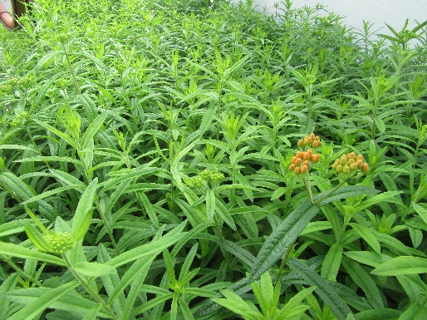The Bessey Nursery also used FY 2016 Native Plant materials funds to collected, clean, stratify, and grow the seeds of the Endangered blowout penstemon. Blowout penstemon are restricted to stabilized sand dunes in Nebraska and Wyoming and planting them into their preferred disturbed habitat ensures the continued survival of the species as well as providing habitat for pollinators and other wildlife. This is a great example of integrating Native Plant Materials funds and expertise to provide benefit for an ESA-protected species as well as pollination and wildlife habitat as a whole.

# US Forest Service Pacific Northwest Region

Working in conjunction with other land owners and partners, the Pacific Northwest Native Plant Program ensures the availability and effective use of native seed and plant materials in terrestrial and aquatic restoration. Plant materials (grass, forb, and shrub seed and seedlings) are used in a wide range of vegetation treatments to reduce erosion, accelerate post-fire recovery, control invasive plants, improve wildlife habitat and pollinator health, and enhance aesthetic qualities and recreational experiences on national forests. This work is foundational to achieving agency goals relating to watershed restoration, ecological biodiversity and resiliency, climate change adaptation, and delivery of ecosystem services and benefits to the public.

Several Forest Service nursery facilities support the Program, including the Bend Seed Extractory (Bend, OR), J. Herbert Stone Nursery (Medford, OR), Clarno Propagation Center (Clarno, OR), and Dorena Genetic Resource Center (Cottage Grove, OR). Private sector nurseries and native seed producers in Oregon and Washington are vital partners. In addition, an ad hoc ‘R6 Restoration Services Team’ (RST) comprised of regional and forest botanists, geneticists, horticulturists, and other specialists, provide revegetation consultations and trainings for R6 personnel, as well as assistance on complex projects. RST also provides revegetation services to an increasing array of federal, state, and county partners throughout the PNW.

## Plant Material Development

These nurseries produce clean native grass and forb seed for multiple forests and other state and federal agencies. This material is used to restore or rehabilitate thousands of acres. Containerized and bare root seedlings are also provided. The Clarno Hardwood Production Facility (OCH NF) provides locally sourced willow and cottonwood cuttings to 16 federal lands partners for riparian restoration plantings. This facility also produces native milkweed seed for monarch butterfly habitat enhancement in central and eastern OR. This work includes an initiative to collect and increase seed supplies for native plants beneficial to pollinator species. In 2016, nurseries had a milestone year, with seed collections or production underway from over 90 different native species and seed sources.

# US Forest Service Intermountain Mountain Region

## Meeting Native Plant Material Needs

Our ability to repair damaged lands and minimize loss of cultural and economic benefits to society largely depends on available, genetically appropriate seed. We are working to advance the availability and use of pollinator-friendly seed mixes in land management, restoration, and rehabilitation. There is an increasing demand for seeds to restore plant communities on both public and private lands in the Intermountain Region and across the country.

## Pollinator Friendly Plant Species

In response to a September 2015 data call associated with the National Pollinator Strategy, the USFS Intermountain Region (R4) identified 80 pollinator friendly native plant species as high priority for seed production. This is a core list of native forbs and shrubs beneficial to pollinators which also provide a high likelihood of success for development under the Region’s native plant program. The species are suitable for enhancing existing pollinator habitat as well as improving pollinator habitat in disturbed areas during revegetation activities. They also contribute to meeting USFS goals for restoration using native plant materials.

## Commercial Increase of Thickleaf Penstemon

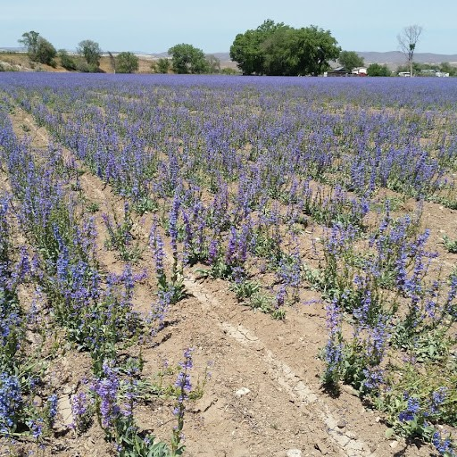The Intermountain Region and Rocky Mountain Research Station collaborated on the contract production of three provisional seed zone sources of thickleaf penstemon *(Penstemon pachyphyllus*). Extensive development work had been completed for this species. It had been screened for agronomic potential, broadly collected throughout the central basin and range ecoregion, trialed in a commercial setting, marketed on the commercial seed market, and utilized on federal restoration projects. The next step was to assemble priority stock seed supplies following the generalized provisional seed zone model. The Native Grass and Forb Seed Increase and Supply contract was used to receive bids from pre-approved seed producers. These seed zone models are being used for the Great Basin:

* 15 – 20 Deg. F. / 3 – 6, CBR, 19 sources (GBRC increase), 24 lbs.
* 15 – 20 Deg. F. / 6 – 12, CBR, 6 sources (wildland), 14 lbs.
* 10 – 15 Deg. F. / 6 – 12, CBR, 6 sources (wildland), 14 lbs.

## Commercial Increase of 5 Sage Grouse and Pollinator Friendly Forbs with the GBRC

This project demonstrates USFS R4 collaboration with the Great Basin Research Center -Utah Division of Wildlife Resources (UDWR) to bulk up seed quantity for five sage grouse and pollinator friendly forb species sources that were collected from the Colorado Plateau Ecoregion on The Ashley National Forest (including Eriogonum umbullatum, Eriogonum racemosum, Lomatium grayii, Lomatium tritenrnatum and Erigeron speciosus). Additional work was then completed to transition these breeder 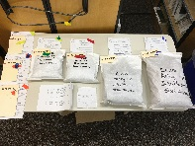stock seed to the commercial seed sector for release as source identified yellow tagged seed. 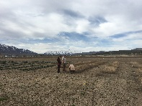

Sage-Grouse Habitat Seed Transfer Zone Study

Forest Service Regions 4 and 1 are currently implementing the 2017 Sage-Grouse Habitat Seed Transfer Zone Study project. Based on the importance of improving sage-grouse habitat and providing key food sources for sage-grouse chicks, Forest Native Plant Coordinators will be collecting seed for two varieties of showy fleabane (Erigeron specious var. marcantha and var. speciosus). The project will ensure appropriate plant material is available and in quantities needed to improve sage-grouse habitat following wildfire and other disturbance. Showy fleabane is also an important pollinator species for bees and butterflies. Participating units in R4 and R1 are currently collecting wildland seed samples of Erigeron specious during the 20l7 field season. Seed samples will be used in a common garden study to develop seed transfer guidelines for a locally adapted, priority revegetation species for our Regions. While Forest Service units are working to collect Erigeron speciosus they will also be collecting or documenting for future collection locations of the following priority sage grouse and pollinator friendly species.

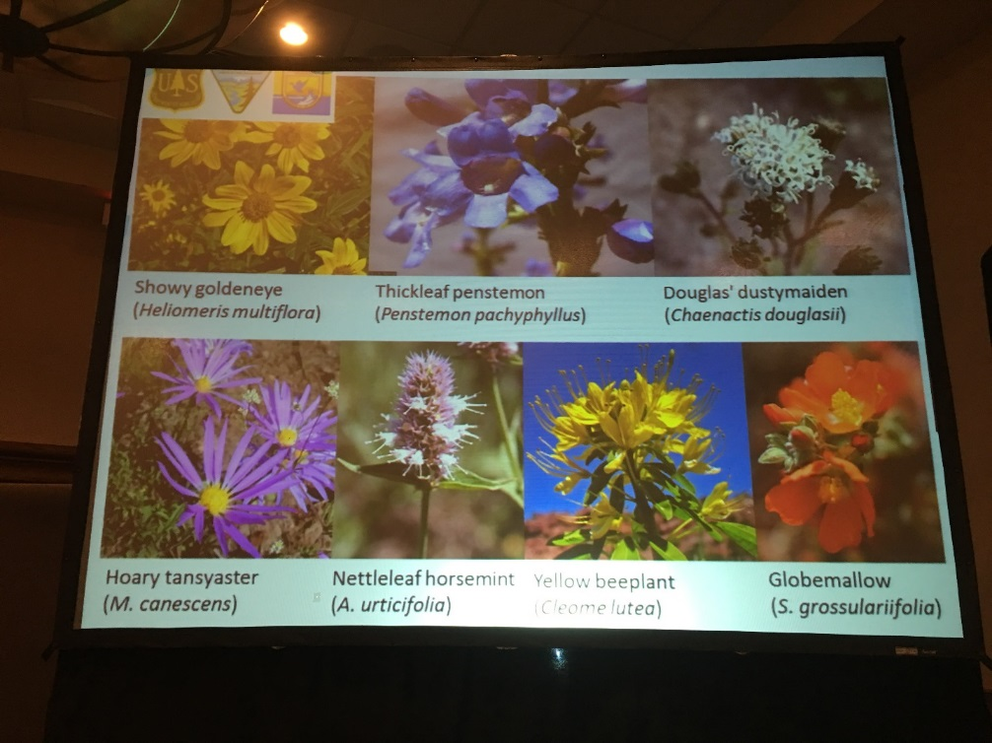

## Eastern Seed Zone Forum

The USDA Forest Service Reforestation, Nurseries, and Genetic Resources team has been assigned the task of determining how best to develop seed zones for the Northeastern Region and the Southern Region. These seed zones are being developed to help the National Forest System address sustainable forest management and ecosystem restoration challenges related to climate change in a uniform manner across regional and political boundaries. These seed zones should be developed in a manner that encourages their adoption by state partners, the Department of Agriculture (USDA), Department of Interior (DOI), state forestry agencies, non-governmental organizations (NGOs), seed producers, land managers, and other interested groups or individuals.

The team includes the Reforestation, Nurseries, and Genetic Resources (RNGR) team, part of the USDA Forest Service State and Private Forestry for Northeast Area, the National Seed Laboratory, USDA Forest 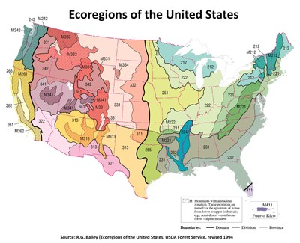Service National Forest System Regions 8 & 9,and USDA Forest Service Southern Research Station. The project objective is to determine seed zones for the eastern US, a region spanning 24 states, from Maine to Minnesota, Texas to Florida. This effort is intended to develop seed zones for trees and smaller subzones for non-woody plants.

The objective is NOT to create recommendations for moving seed across the landscape, also known as “seed transfer guidelines.” The science of seed transfer is in its infancy, and not within the scope of this project. Instead, the primary goal is to develop a common lexicon for discussing locality across administrative barriers. This work will aid land managers who wish to move seed in the future for assisted migration. The Eastern Seed Zone Forum developed a website for collaboration and information sharing (<http://eszf.sref.info/>).

# US Forest Service Nurseries

## Bend Seed Extractory

The Bend Seed Extractory in the Pacific Northwest Region purchased new equipment, upgraded existing equipment and developed & documented new technologies for processing the ever-increasing native species seed needs of the Federal seed program. Reporting numbers reflect extractory accomplishments for the seed year which runs August 1, 2015 through May 31, 2016.

Number of diverse native species and pounds processed:

* 8,971 pounds of material from R6 JH Stone Nursery resulting in 3,754 pounds of clean seed.
* 1,494 separate collections (4,816 pounds) of wild seed were processed, tested, and packaged, resulting in 986 pounds of clean seed.
* 1,476 bushels of conifer collections were processed resulting in 426 pounds of conifer seed from six different species.
* 239 individual collections were made across the western US for gene conservation by USFS geneticists. The seed came from nine different species and resulted in 20 pounds of conifer seed.

## J Herbert Stone Nursery

2016 Seed Increase Production includes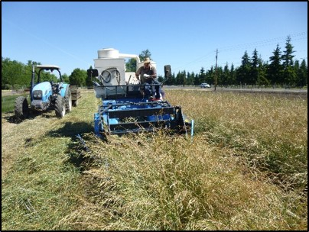 ‘Threatened & Endangered’: Cook’s desert parsley (Lomatium cookii, T&E), Wooly meadowfoam (Limnanthes pumila grandiflora T&E), Showy milkweed (Asclepias speciosa), Giant blue-eyed Mary (Collinsia grandiflora), Sulfur buckwheat (Eriognum umbellatum), Winecup clarkia (Clarkia purpurea), Yarrow (Achillea millefolium), Canada goldenrod (Solidago canadensis), Pearly-everlasting, (Anaphalis magaritacea), California, Idaho, & Roemer’s fescue (F. californica, F. idahoensis, & F. roemerii), Blue wildrye (Elymus glaucus), Lemmon’s needlegrass (Acnatherum lemmonii), Slender hairgrass (Deschampsia elongata), Junegrass (Koeleria macrantha), California brome (Bromus carinatus), Harford’s oniongrass (Melica harfordii)

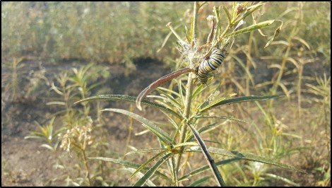

# US Forest Service Dorena Genetic Resource Center

## Restoration Project Implementation

The Dorena Genetic Resource Center provided native plant materials and staff for developing and implementing R6 Restoration Services Team projects in the PNW. These projects included 1) 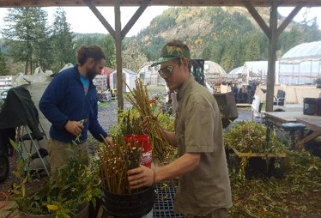implementing seeding and outplanting on 5 harsh site restoration projects in Oregon and Idaho, including wetland restoration, rockfall mitigation, and pipeline/road construction rehabilitation. 2) providing genetically appropriate, locally adapted native trees, shrubs, and forbs for 9 restoration projects in Washington, Oregon, and Idaho, including the Historic Columbia River Highway State Trail and various upland and wetland rehabilitation projects and 3) completing initial planning and revegetation plans for 3 new projects (with 3 new partners) in Oregon.

## Native Species Plant Materials

The Resource Center produced native tree, shrub, forb and graminoid species to assist J Herbert Stone Nursery; for the Pacific Northwest Region Restoration Services Team (RST) projects, and for pollinator habitat development:

* Propagated a total of 71,000 plants from collected seeds and vegetation, including 57 species for 5 National Forests and 5 outside agencies;
* Developed 25 new protocols for growing shrubs, forbs, and ferns, including 16 pollinator habitat species;
* Provided seed and vegetation collection assistance to 3 National Forests and 4 RST projects.

Forest Service Research & Development

## The Great Basin Native Plant Project: Providing knowledge, technology, and availability of native plant materials across the Great Basin.

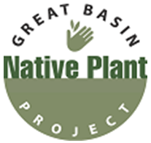Demand for native plant seed is increasing, especially in federal agencies including the US DOI Bureau of Land Management (BLM) and the Forest Service. Invasive species, shifting fire regimes, and rapid climate change increase the need for researchers and land managers to develop successful management practices.

[The Great Basin Native Plant Project](http://www.greatbasinnpp.org/) seeks to increase the availability of genetically appropriate native plant materials and to provide the knowledge and technology required for their use in restoring diverse native plant communities across the Great Basin. This multi-state, collaborative research project was initiated in 2001 by the [Plant Conservation Program](http://www.blm.gov/wo/st/en/prog/more/fish__wildlife_and/plants.html) of the BLM and the Grassland, Shrubland, and Desert Ecosystem Research Program of the Rocky Mountain Research Station.

To help managers restore landscapes with a holistic, biologically diverse ecosystem that benefits wildlife, agriculture and humans, Forest Service researchers and their partners are breeding native plant varieties, such as bluebunch wheatgrass, that fit well with local and regional climates. There are more than 30 major cooperators in nine states currently working together to meet objectives of the Great Basin Native Plant Project. In 2016-17, the GBNPP delivered findings on 29 projects in its annual report. Some examples include:

* Testing the efficacy of seed zones for re-establishing and adaptation of bluebunch wheatgrass.
* Population and species-level variation in germination strategies of cold desert forbs.
* Seed production of Great Basin native forbs, with special attention to irrigation requirements.
* Drought effects on the symbiosis between Wyoming big sagebrush seedlings and arbuscular mycorrhizal fungi.

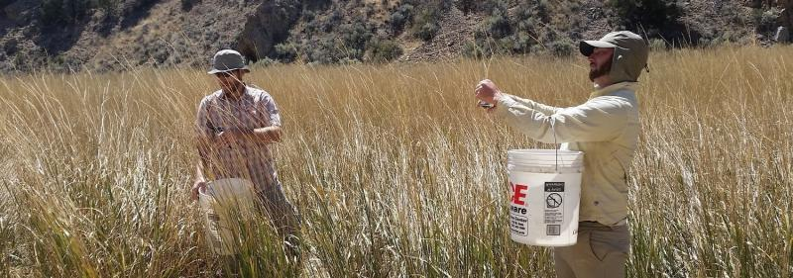

Seedlot Selection Tool

FS R&D has created the Seedlot Selection Tool (SST) which is a web-based mapping application designed to help natural resource managers match seedlots (seed collections from a known origin) with planting sites based on climatic information. Matching the climatic adaptability of plant materials to the climatic conditions of reforestation or restoration sites improves success. For forest trees, and increasingly for other native plants, this has typically been done using geographically defined seed zones or seed transfer rules that specify a geographic or climatic distance beyond which populations should not be moved.

However, these recommendations assume that climates are stable over the long-term—an assumption that is unlikely given projected change. To address this problem, climate-interpolation models are now available that can be used to define zones and transfer limits based on climate rather than geography. The SST can be used by managers and other stakeholders to map either current or future climates based on selected climate change scenarios. It allows users to select a transfer limit method (using an established seed zone or creating a customized one), a climate scenario, and a set of relevant climate variables, to map either seedlots that are appropriate for planting on a particular site or sites that are appropriate for a particular seedlot. When future climate scenarios are chosen, the tool allows consideration of seedlots that may be adapted to future climates, a management option often referred to as assisted migration. The SST can be accessed at <https://seedlotselectiontool.org/sst/>.

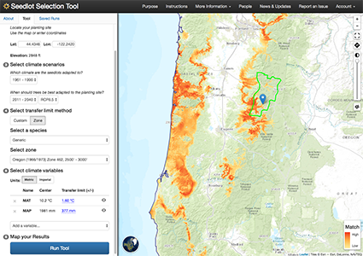

**Application display:** The SST maps potential seed sources for a planting site while considering potential future climates. Orange areas indicate best suitability for the stated goal given a set of climate constraints

# FS R&D helps Tribes learn new strategies to restore their native lands



The Forest Service’s Reforestation, Nurseries, and Genetic Resources Team provides an important forum for Native American tribes to network regarding native plant production and restoration. Team leaders have worked with nearly 80 tribes and one-on-one with more than 500 tribal members across the United States and Canada, teaching them how best to propagate culturally significant plants for their own uses. Native peoples are seeking out expertise on native plant propagation as they increasingly work to restore their lands with culturally significant native plants. Scientists at the agency’s Rocky Mountain Research Station are currently working on writing nearly 300 native plant propagation protocols requested by different tribes. Several awards have recognized the quality and effectiveness of the team’s efforts, including the Earle R. Wilcox Award from the Intertribal Timber Council.

*16th Annual Workshop Intertribal Nursery Council Meeting Participants.*

In 2016, Forest Service scientists co-organized the 16th annual Intertribal Nursery Council workshop in Buffalo, New York, hosted by the Seneca Nation of Indians. Participants from tribes across the U.S., federal agencies, universities and tribal colleges, county and city governments, and private entities attended. The meeting included technical and information sharing presentations, field tours, a traditional dinner, and a mini-workshop on seed germination and storage. The event was well-received among tribal participants, with open discussions promoting the use of native plant nurseries for tribal restoration projects, reforestation, education, cultural preservation, and science.

The Intertribal Nursery Council is a USDA Forest Service managed and funded tribally guided organization for advancing the interests of native peoples involved with plant production in nurseries.

# Helping to make prudent, research-based decisions to improve shrublands in the Interior West

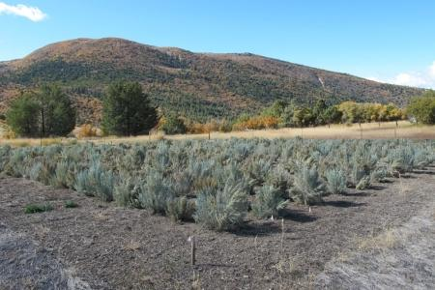Shrubs are the cornerstones of arid ecosystems in the West, mitigating soil erosion, fostering plant and animal biodiversity, storing carbon, and providing cover and forage for wildlife such as the greater sage-grouse. The shrub-dominated ecosystems are being compromised by increased fire frequency and size, coupled with invasive plants, mainly cheatgrass. Subsequently, post-fire restoration has become a fundamental component for maintaining ecosystem function and resiliency in these shrublands.

Healthy sagebrush common garden at Great Basin Experimental Range.

Many of the restoration plantings currently used in the Intermountain West include big sagebrush seed collected from naturally occurring populations. In addition, increased wildfire frequency and the introduction of invasive annual grasses in the Mojave and Colorado Plateau have increased the need to restore blackbrush ecosystems. Shrubland restoration through wildland plantings is most effective when the plant materials used are site-adapted and have appropriate levels of genetic diversity promoting resilient ecosystems, now and in the future. Moving plant materials responsibly requires knowledge of how plant populations and species are adapted across variable environments.

Studies in which plants representing multiple populations of a single species are grown together in common environments provide a useful approach for ascertaining species limits. Two common gardens have been established for big sagebrush and blackbrush at the [Great Basin](https://www.fs.fed.us/rmrs/experimental-forests-and-ranges/great-basin-experimental-range) and [Desert Experimental Ranges](https://www.fs.fed.us/rmrs/experimental-forests-and-ranges/desert-experimental-range) in Utah, respectively. These experimental areas are ideal for these studies because of shrub-dominated naturally occurring vegetation, historical and ongoing weather data collection, and protection from livestock use.

# Researching Native Plants

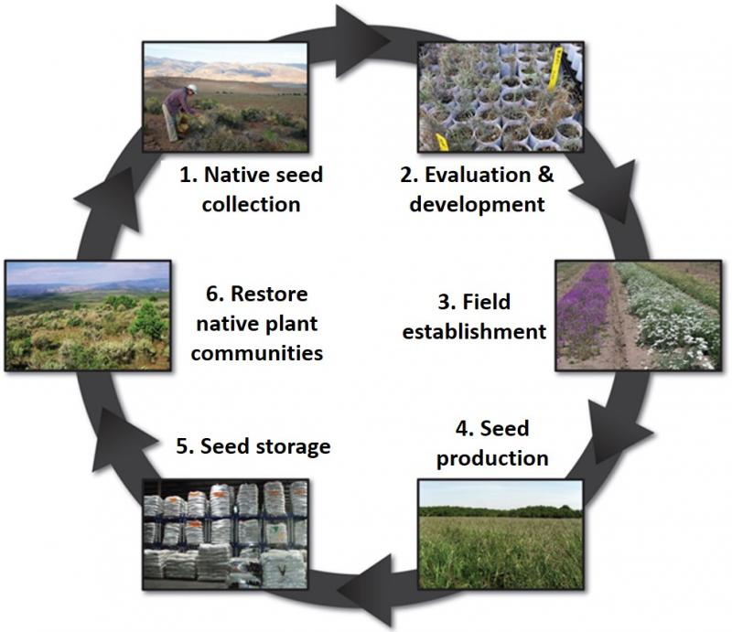Researchers from the Forest Service with the Great Basin Native Plant Project focus on genetics, species-specific seed zones, rapid testing and provisional seed zones, and the establishment of a common garden network to assess the suitability of native seeds for different climates. The most robust seeds become the foundation for restoration projects to rebuild ecosystems after big wildfires, such as those currently wiping out vast sagebrush expanses in Nevada, Idaho and Utah.

"Common garden studies" are a particularly valuable approach for comparing the performance of native seed. Researchers gather native seeds from different areas of the country with different climates and grow the seeds together in a single garden. The seeds experience the same environmental conditions in the common garden, allowing researchers to compare growth and performance of the different varieties. In other words, common garden studies for plants are similar to "twin studies" done on humans to separate the effects of nature versus nurture.

Another research focus is creating an adequate supply of different varieties of native seed mixes. Using one variety of a species during large, landscape-scale restoration projects raises concerns. Genetic diversity can ensure seeds have a variety of traits, such as drought tolerance, that can help the species establish and persist into the future.

The Great Basin Native Plant Project also focuses on sharing knowledge about successful seeding of native species with land managers. The research group report findings through publications such as annual reports, plant guides, journal articles, and brochures, as well as through face-to-face workshops and conferences with scientists and managers.

Success on a national scale will continue to happen through a nationwide network of native seed collectors, a network of farmers and growers working to develop seed, a network of nurseries and seed storage facilities to supply adequate quantities of appropriate seed, and a network of restoration ecologists who know how to put the right seed in the right place at the right time.

# The intersection of science and technology transfer: Reforestation, Nurseries, and Genetic Resources Team

[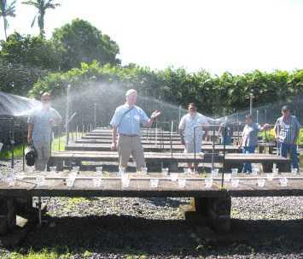Reforestation, Nurseries and Genetic Resources (RNGR)](http://www.rngr.net/) specialists provide necessary on-site support to nursery managers to improve production of native plants for reforestation and restoration.

The team was established through a Forest Service memorandum of understanding and is tasked with transferring information on native plants, including their collection, propagation, and deployment. This team is composed of three Forest Service regional nursery specialists, the director of the National Seed Laboratory, and two scientists from the Rocky Mountain Research Station (RMRS) – Kas Dumroese and Jeremiah Pinto.

The team ensures that nursery managers, reforestation and restoration specialists, and others in related fields receive timely information. The growers and users of the approximately one billion native plants (grasses, forbs, shrubs, and trees) produced each year in the United States must have the best information to assure that (1) production can be as efficient as possible, (2) outplanting performance justifies costs, and (3) reforestation and restoration plantings meet desired outcomes. This need is especially apparent in underserved communities, such as Native Americans and citizens of the U.S. insular areas (*e.g.*, Puerto Rico, the United States Virgin Islands, and American Samoa).

Over the past decade, Dumroese and Pinto have helped ensure that RNGR projects and programs have a sound scientific foundation and are effectively executed. They are also responsible for producing [Forest Nursery Notes](http://www.rngr.net/publications/fnn). The publication, produced twice a year, synthesizes topical, practical articles for native plant producers, and includes a bibliography of current literature.