ANNOUNCEMENT

New Web Tool Provides Climate-Smart Seedlot Selection Recommendations

Intuitive tool simplifies choice of seed sources for 21st century reforestation and restoration efforts

The U.S. Forest Service, Oregon State University and the Conservation Biology Institute have launched a free web-based decision-support tool to help natural resource managers match seedlots (seed collections from a known origin) with planting sites based on climatic information.

Populations of trees and other native plants are genetically different from one another and are adapted to different climatic conditions. Therefore, natural resource managers must match the climatic adaptability of their plant materials to the climatic conditions of their planting sites. Typically, this has been done using geographically defined zones (e.g., seed zones or breeding zones) or seed transfer rules that specify a geographic distance to be moved. However, current climate models can now be used to define zones based on climate, rather than geography.

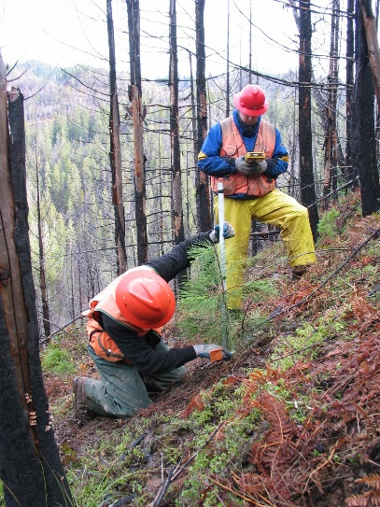
Photo credit: Paul D. Anderson, USFS.

The new web-based mapping application, called the Seedlot Selection Tool (SST), can be used to map either current climates or future climates based on selected climate scenarios. The tool is particularly valuable for considering options for responding to climate change. Because plant populations are generally considered to be locally adapted, climate change will likely lead to declines in health and productivity of native ecosystems. The SST will allow consideration of seed sources that may be adapted to future climates, a management option often referred to as assisted migration or assisted gene flow.

The SST allows users to select a tree species, a transfer limit method (using an established seed zone or creating a customized one), a climate scenario, and a set of relevant climate variables, to display seedlots that are appropriate for planting on a particular site or the sites appropriate for planting seedlings from a particular seedlot.

The application allows the user to control many input parameters so the results can reflect the management practices, available knowledge of adaptation, climate change assumptions, and risk tolerance of the user. Because of the uncertainty in climate projections, this application really is a planning and educational tool. It can be used to explore alternative future conditions, assess risk, and plan potential responses, but cannot tell the user exactly from which seedlot seedlings will be optimally adapted to a particular planting site in the future.

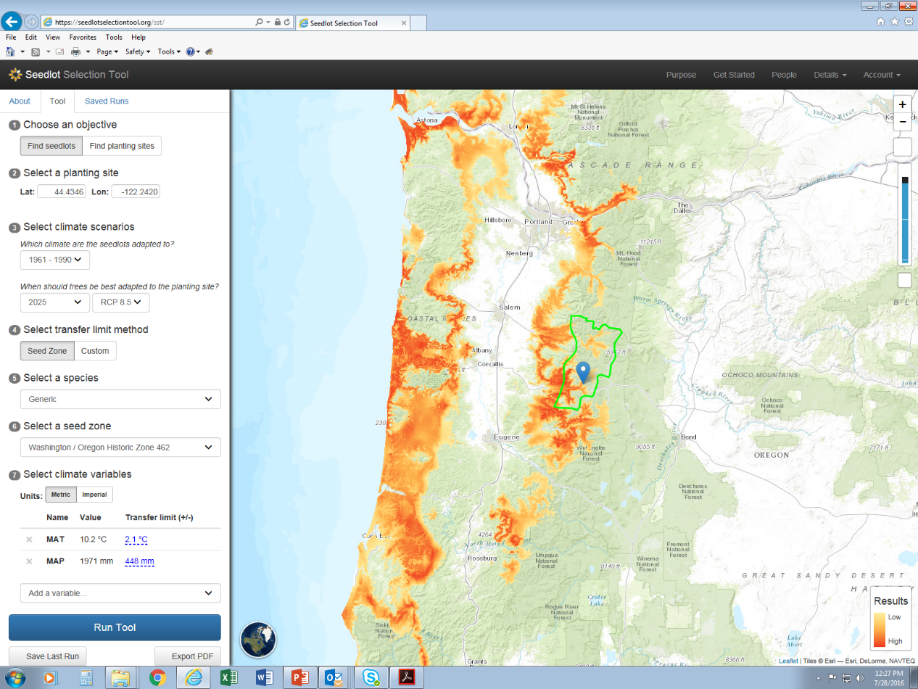Application display: The SST maps potential seed sources for a planting site, while considering potential future climates. Orange areas indicate best suitability for the stated goal given a set of climate constraints.

The SST currently covers the western conterminous United States and adjacent Canada and Mexico. The goal is to extend the tool to Alaska and the entire conterminous U.S. Regular updates on progress towards that goal will be posted on the web site and sent to registered users (http://bit.ly/2cj6PqD).

Accessing the tool and additional information
More on the tool including detailed instructions are available on the web site: https://seedlotselectiontool.org/sst/.

The SST is a joint project of the U.S. Forest Service (USFS), Oregon State University (OSU), and the Conservation Biology Institute. Initial conceptualization and development was done by Glenn Howe at Oregon State University and Brad St. Clair at the USFS Pacific Northwest Research Station. Further development, design, and programming were done in collaboration with Dominique Bachelet, Nikolas Stevenson-Molnar, and Brendan Ward at CBI. The application's source code was written by Nik Stevenson-Molnar and is available at https://github.com/consbio/seedsource.

Funding for the SST came from the USFS, OSU, and the USDA Northwest Climate Hub.

