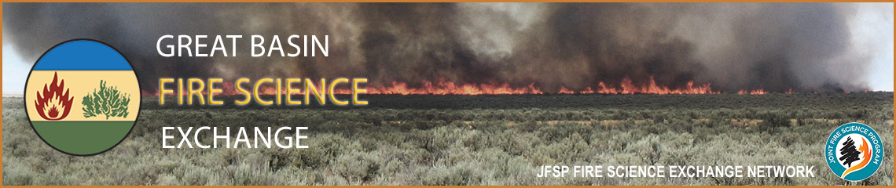
Webinar Brief for Resource Managers
Great Basin Fire Science Exchange | 1664 N. Virginia St., Reno, NV 89557 | 775-784-1107 | emb@cabnr.unr.edu

Seed Zones: Development and use, procurement and deployment, and provisional seed zones for native plants

To Be Presented on 29 January 2015 by Brad St. Clair, Research Geneticist, USFS Pacific Northwest Research Station; Vicky Erickson, Geneticist, USFS Pacific Northwest Region; and Andy Bower, Geneticist, Olympic National Forest
Management Implications

- Differences among native plant populations that make sense for survival, growth and reproduction in various source climates indicate that genetic variation across the landscape is adaptive and should be considered during restoration.
- Seed zones have been developed for several key native species used in restoration in the Northwest.
- Generalized provisional seed zones are useful for the many restoration species that will likely continue to lack information on adaptation and population variation.
- Seed zones help ensure restoration success, while increasing efficiency and reducing the cost of native seed production and use.

Project Summary:
Seed zones have been developed in the Northwest for several native species used in restoration based on genecological studies. Provisional seed zones for species lacking genetic knowledge have been developed based on generalizations about climatic variables important for adaptation. Seed zones have helped ensure restoration success for Forest Service projects while allowing for increased efficiencies and reduced costs by facilitating sharing over a reduced number of management units.

Abstract:
A seed zone is an area in which plant materials collected from natural stands can be transferred with little risk of being poorly adapted to the new location. Seed zones and population movement guidelines have a long history in forestry to help ensure successful reforestation and productivity of forest stands. More recently seed zones have been developed for shrubs, grasses and forbs used in restoration and re-vegetation based on knowledge of geographic genetic variation in adaptive traits as determined from common garden studies. This presentation serves as an introduction to the methodology of studying adaptation and seed zone delineation based on genecology and reciprocal transplant studies. For species lacking genetic knowledge, generalized provisional seed zones have been developed based on the intersection of high resolution climatic data for winter minimum temperature and aridity, with consideration given for differences among ecoregions. These provisional seed zones can be considered a starting point for guiding seed transfer and should be utilized in conjunction with appropriate species-specific information as well as local knowledge of microsite differences. Application and benefits of seed zones to operational programs and activities are illustrated via examples from the Forest Service PNW Region. Here, seed zones are integrated into all aspects of native plant material development and use, including seed need planning and the collection, propagation, and deployment of seed and planting stock for restoration.

Most Relevant References:
Bower, A.D., J.B. St.Clair, and V. Erickson. 2014. Generalized provisional seed zones for native plants. Ecological Applications 24: 913-919.

Erickson, V.J. 2008. Developing native plant germplasm for national forests and grasslands in the Pacific
Northwest. Native Plants Journal 9(3): 255-266.

St.Clair, J.B., F.F. Kilkenny, R.C. Johnson, N. L. Shaw, and G. Weaver. 2013. Genetic variation in adaptive traits and seed transfer zones for Pseudoroegneria spicata (bluebunch wheatgrass) in the northwestern United States. Ecological Applications 6: 933-948.

