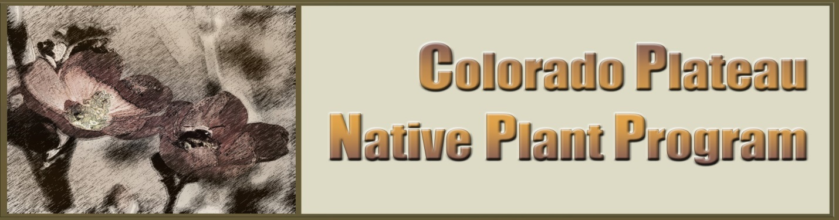
CPNPP 2016 Annual Meeting
March 22 & 23, Page AZ, 8am – 5pm
Courtyard Page Hotel at Lake Powell*

Presentation and Discussion Topics will include:
- National and Regional Program & Initiative Update
- Plant Materials Research & Development News
- Industry Perspective, Activity & Updates
- Seed/ Plug/ Container Production, Storage & Use
- Partner Communication & Collaboration

Registration is Free.
Contact: Adrienne Pilmanis, CPNPP Coordinator, at apilmani@blm.gov or 801-539-4076 to:
- Register. Provide name, affiliation, contact information
- Submit Abstracts by January 15
- Reserve Exhibit Space (free)
- Sponsor Meeting Breaks. Event menu available at http://www.marriott.com/hotelwebsites/us/p/pgacy/pgacy_pdf/EventsMenu1.pdf (see Reception section)

*Lodging: Call 877-705-4495 to reserve $99 room rate by February 20. Specify “Colorado Plateau Native Plant Program Annual Meeting”. Other local options available.

