EPA would like to identify members of the scientific community who could provide information and/or literature references about at-risk plant species or plant communities that can support sensitive and/or at-risk insect species in the vicinity of the juncture of Oklahoma, Kansas, and Missouri. The information will be used to support plant selection for revegetation of a Superfund site located in that area of the Midwest.

EPA would like to identify plant species or plant community assemblages native to that area that can
- Tolerate relatively high metal (especially zinc and lead) concentrations in soil;
- Help restore healthy soil and plant communities by fixing nitrogen, providing soil organic carbon, and/or supporting beneficial microbial communities; and
- Serve as host plants, food plants, or create habitat that benefits insect species that include
  - Pollinators (bees, wasps, beetles, butterflies, moths, flower flies, etc.);
  - Insect predators of pest species (predatory beetles and stink bugs, mantises, dragonflies, parasitoid wasps, etc.);
  - The insect prey of sensitive or at-risk non-insect consumers (bats, birds, amphibians, reptiles, etc.), and
  - At-risk insect species not yet on federal or state lists for species-of-concern (such as the migratory monarch butterfly, various bumble bee species, etc.).

EPA is planning revegetation efforts for the Tar Creek Superfund Site located in Ottawa County, Oklahoma. The site is a former lead and zinc mining area and consists of the Oklahoma portion of the Tri‐State Mining District of Oklahoma, Kansas, and Missouri. The site is approximately 40 square miles in size and includes those areas of Ottawa County where lead and zinc mining activities occurred or where a hazardous substance from mining or milling was stored or disposed.

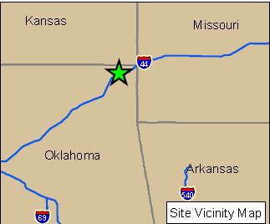

The mining area principally includes the communities of Picher, Cardin, Commerce, Quapaw, and North Miami. As a result of the mining and milling operations, large quantities of mining wastes were deposited on the surface in piles (coarse tailings known as “chat”), and large “ponds” (now dry) filled with fine tailings. These features are scattered throughout the 40-sq.mi. area that is sparsely populated and used primarily for agriculture and pasture. Property ownership is either Tribal or non‐Tribal, or a combination of both.

The EPA will be addressing materials that contain chemicals of concern (cadmium, lead, and zinc) at levels that could result in unacceptable risk to human health and the environment. Cleanup will include soil disturbance. After cleanup is complete, EPA will be managing revegetation of portions of the 40-sq.mi. area.

To design the scope of revegetation, EPA would like to include consideration of native plants that can restore soil fertility and provide wildlife habitat. EPA would appreciate any information the scientific community can provide to guide these efforts. Individuals or institutions who wish to provide advice or identify relevant literature in the future may contact Deana Crumbling, environmental scientist with the USEPA Superfund Program in Washington, DC. Office phone = 703-603-0643; office email = crumbling.deana@epa.gov.

