Figure 1. American ginseng conservation status rank in the United States and Canada (NatureServe 2000).

 | SH: | Possibly Extirpated
 | S1: | Critically Imperiled
 | S2: | Imperiled
 | S3: | Vulnerable
 | S4: | Apparently Secure
 | SR: | Reported
 | Under Review

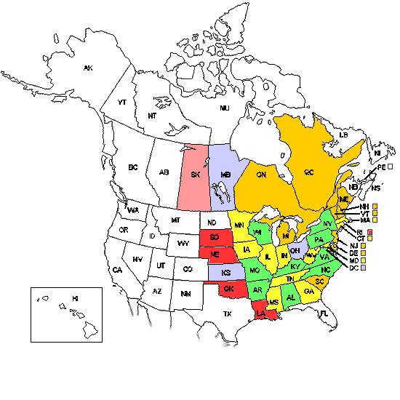

28

